Saul Bass
-Saul Bass has made movie posters for Alfred Hitchcock, Stanley Kubrick, Otto Preminger, Billy Wilder and Martin Scorsese.
-First became known in film after creating the title sequence for “The Man with The Golden Arm” made by Otto Preminger in 1955
-He worked with Elaine Makatura on opening title sequence of Spartacus
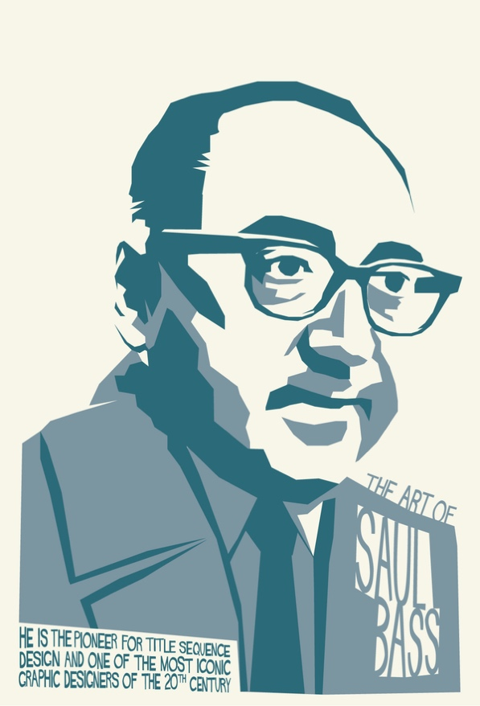
-Later married her and worked alongside her on most of his projects after
-Worked on two pavilions for the worlds fair, “From Here to There” for United Airlines and “The Searching Eye” for Eastman Kodak
-Also made a short film “Why man creates” which won an Oscar
-After not working for many years Bass came back to do work for James L. Brooks and Martin Scorsese, he made the opening titles for Goodfellas, Cape Fear, The Age of Innocence and Casino.
Bauhaus designed chair. It is Minimalistic and serves its purpose
-Saul Bass was inspired by the Arts and Crafts movement and the Bauhaus school. The Arts and Crafts movement was a movement centred around traditional craftsmanship and using simple forms. This Movement was between 1880 and 1910 in Europe and North America, in the 1930’s it was replaced by Modernism.
-The Bauhaus was an art school in Germany that centred around combing crafts and fine art.
-Another movement going on at the time was minimalism, which you can see from his work he was a leader in.

Logos
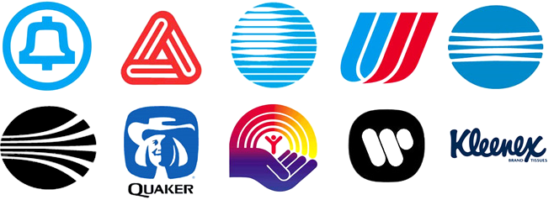

Saul Bass has also designed many logos for many well known companies. Each one is simple and memorable and conveys what the company wants you to think about them. For example, when I look at the Kleenex logo I think of softness and cleanliness and when I look at the Quaker logo I think of wholesome and natural.

Movie Posters
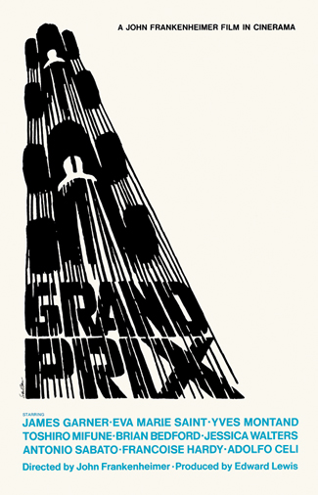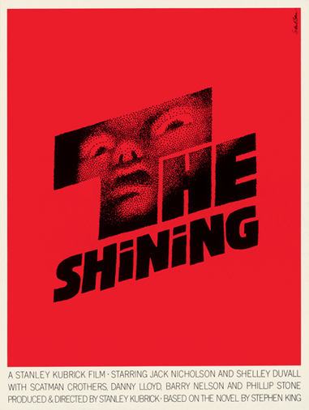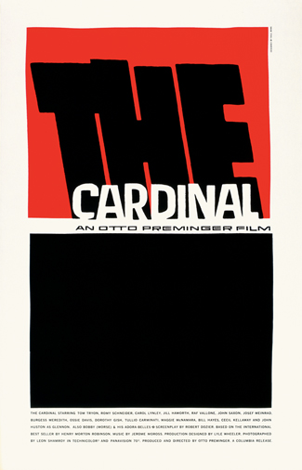
Saul Bass’s movie posters are simple in their execution but wildly effective. Using very simple colours and shapes he can convey the tone of the movie. Keeping the posters simple makes them more memorable. He explains this technique through the quote “Symbolize and Summarize” You remember something simple like his Shining Poster rather then what (most) movie posters are now which will just show a character or a scene from the movie. His Posters are art pieces in and of themselves.

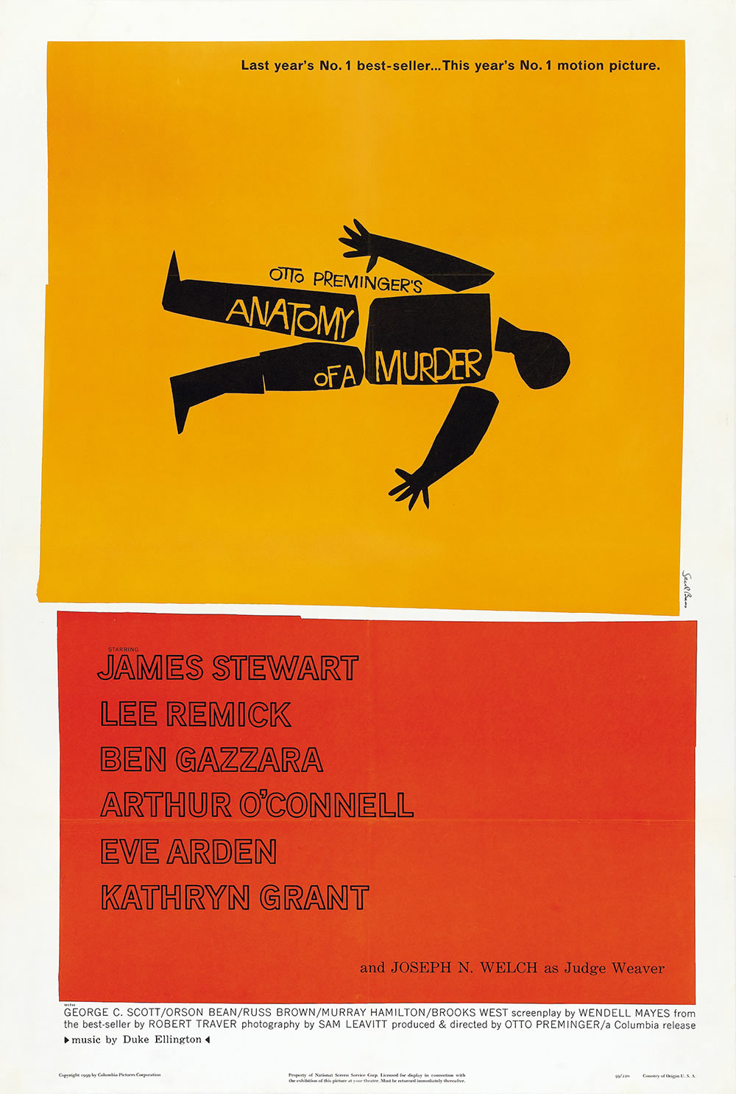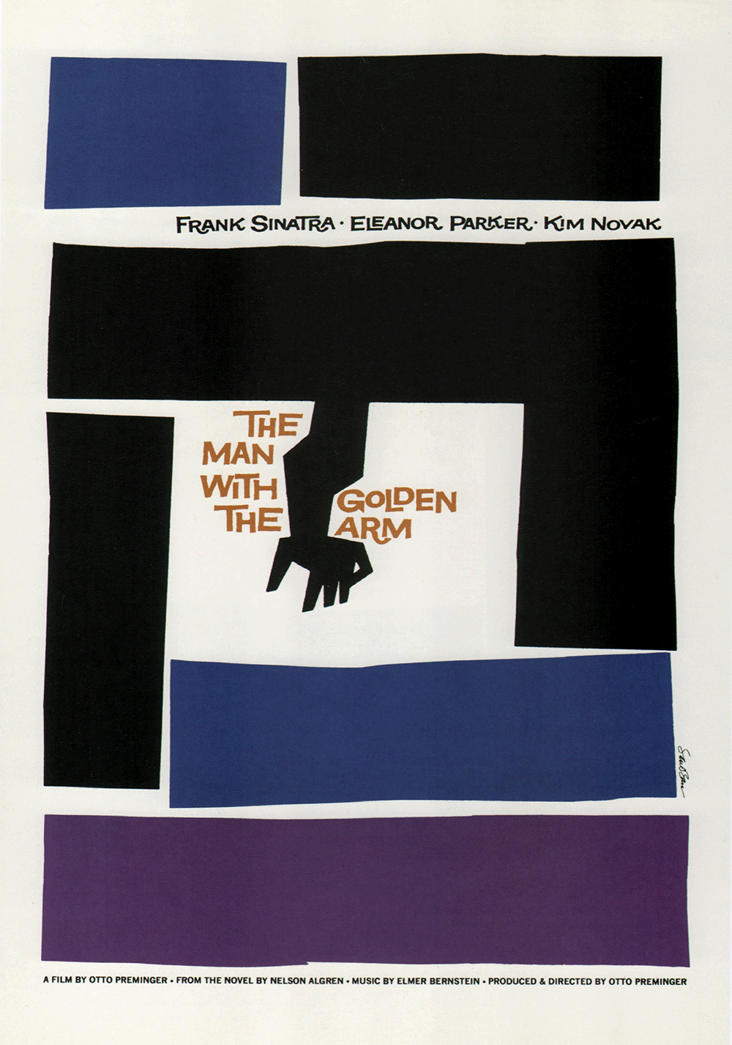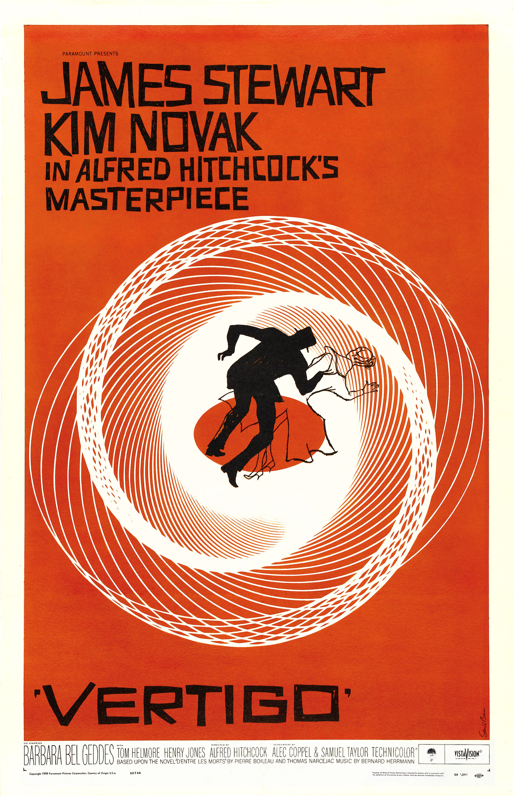

Title Sequences
Saul Bass has also developed many title sequences. The title sequence is an integral role to a movie because it is the first thing you see in a movie and sets up the tone for the entire movie. Saul Bass, like he did with his movie posters also did a great job of setting up these movies. He has done a wide variety of movies with a different style, but all of them do have one thing in common, they are simplistic in their execution but convey the theme and tone of the movie perfectly. The movies where he designs both the title sequence and movie posters are extremely similar in style, making for a fluent experience from poster to movie.

What made Saul Bass’s movie posters and title sequences so successful?
What art movements was Saul Bass inspired by?
http://www.artofthetitle.com/designer/saul-bass/

https://www.logomaker.com/blog/2012/11/26/10-quotes-about-logo-design-from-saul-bass/

http://www.aiga.org/The-Saul-Bass-Approved-Method-of-Credibility-Based-Logo-Design/

http://www.theguardian.com/artanddesign/2011/oct/30/saul-bass-life-film-review

