ROY LICHTENSTEIN

About:
Roy Lichtenstein was an American pop artist during the 1960’s. He was a painter, sculptor, and printmaker. He was a key player in the Pop-Art movement along with Andy Warhol,
Jasper Johns, and James Rosenquist.

Bio:
1923 - Born in New York City on October 27th
- Grew up in upper west side of Manhattan
- Passion for science and comic books
- Became interested in art as a teenager
1937- Took watercolour classes at Parsons School of Design
1940 - Took classes at the Art Students League
1943 - Sent to Europe for WWII
- Returned and finished his degree and masters in fine arts
- Moved to Cleveland, worked as window display designer, industrial designer and commercial-art instructor
1940s - Exhibited his art nationwide
1960s - Began experimenting with subjects and methods
- Art began to comment on popular American culture
- Reaction to Abstract Expressionist painting

Style:
In the 1940s Abstract Expressionism was developed. Although this was the popular style Roy Lichtenstein was unlike expressionist artists like Jackson Pollock, and Willem de Kooning. Roy Lichtenstein was different because he took imagery from other sources. He didn’t emphasize on the way he painted, the way that abstract expressionist painters did0 because he didn't use emotion. He was inspired mainly by advertisements and comics, and focused on a more commercial style, sometimes using stencil drawings and imitating mechanical printing. His art reflected culture rather than his individual feelings. Because of this Roy Lichtenstein shifted from Abstract Expressionism, and along with Andy Warhol encouraged the beginning of the Pop-Art movement.

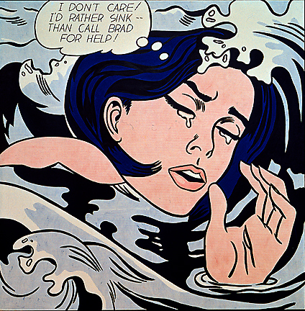 | Drowning Girl - 1963  -Oil and synthetic polymer painting on canvas  -(171.6 x 169.5cm)  -Displayed in the Museum of Modern Art, New York City  -Inspired by comic book art  - Appropriated the image from Tony Abruzzo’s panel used for “RUN FOR LOVE” in a DC Comic series, Secret Hearts
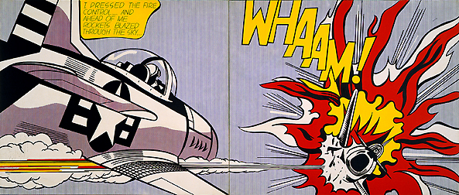 | Whaam! - 1963  -Acrylic paint and oil paint on canvas  -(172.7 x 406.4cm)  -Inspired by the DC Comic series “All American Men of War”

Questions:
- How did Roy Lichtenstein shift from Abstract Expressionism?
- What was Roy lichtenstein’s main inspiration?

Sources:
http://www.theartstory.org/artist-lichtenstein-roy.htm
https://www.moma.org/learn/moma_learning/lichtenstein-drowning-girl-1963
http://www.tate.org.uk/art/artworks/lichtenstein-whaam-t00897
http://www.notablebiographies.com/Ki-Lo/Lichtenstein-Roy.html

