Prepping A Pencil Sketch
For turning a scanned sketch ito a vector image on illustrator or or colouring a scanned sketch on photoshop

So you've got a great sketch, and you like it just how it is... except it's really far too light to color. This tutorial explains how to darken and clean up your sketch in Photoshop.
Start by scanning your drawing into Photoshop. If you're planning on coloring the drawing after the clean-up, scan at 200dpi (dots per inch) or greater so that you are able to get in all the little details.

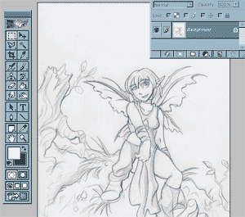

Under the image menu, pull down the "Levels" option.

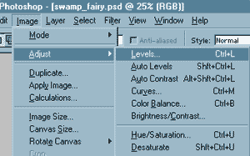

Pulling the arrow on the right in will make your whites whiter, and pulling the arrow on the left will make your darks darker. Pull them in until you are satisfied with how the contrast looks. If you are unsure, pulling in until the top of each arc will usually give you a fairly balanced drawing.

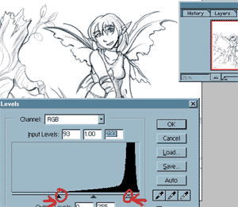

If you are not going to be coloring, then you are ready to save AND CAN NOW OPEN IN ILLUSTRATOR. If you DO plan on coloring your image, pull up your layers menu. Set the dropdown box from normal to multiply. This will allow you to color underneath the sketch.

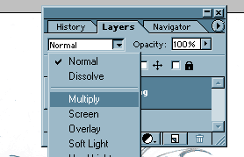

Create a new layer for the color. If you try to color on the drawing layer itself you'll lose your lines and shading.

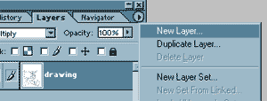

Drag the color layer underneath your drawing layer. You are now ready to color your image! If you would like to see how this particular image was colored, check out the "Another approach to CG" tutorial.
