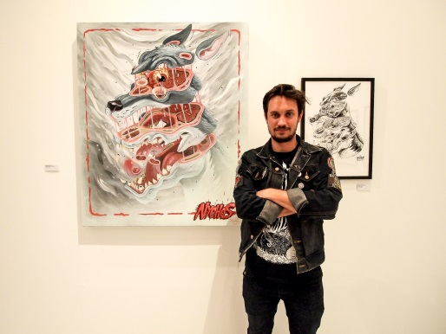
Nychos The Weird
Nychos is a urban art and graffiti illustrator from Austria. Born on 1982 in Styria, Austria Nychos grew up in a hunting family. Being an 80s kid who had a strong interest in Cartoons, while having a love for heavy metal fueled his desire to take up graffiti at the age of 18. Over the years Nychos had developed a distinctive art style which easily stands out. His art style consists of dissections and cross sections of human and animal bodies. The mix of dissected motives and the combination of colorful outlines can be seen as his branding.
He is most well-known for his large and technically outstanding art pieces in the urban environment and in several different gallery exhibitions. He is currently seen as one of the most sought-after artists on the street art scene.
Rabbit Eye Movement
In 2005 Nychos created his own “movement” called The Rabbit Eye Movement. This movement fueled and defined his art work spread on the streets for the next 7 years. In 2012 he opened the REM headquarters located in the heart of Vienna, the REM art space is now a full time gallery and studio.
“I created the ‘Rabbit Eye Movement’ as a homage to all the people out there who are active in the Urban Art Movement. It doesn’t matter what kind of mission they are following” – Nychos
REM promotes a network of different artists, both national and around the world with a background of illustration. There are about 20+ artists that are following this “movement”
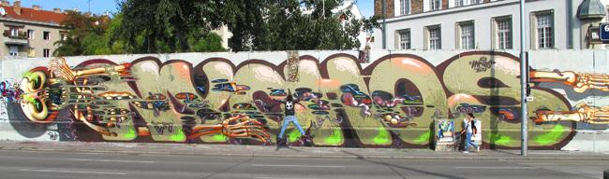
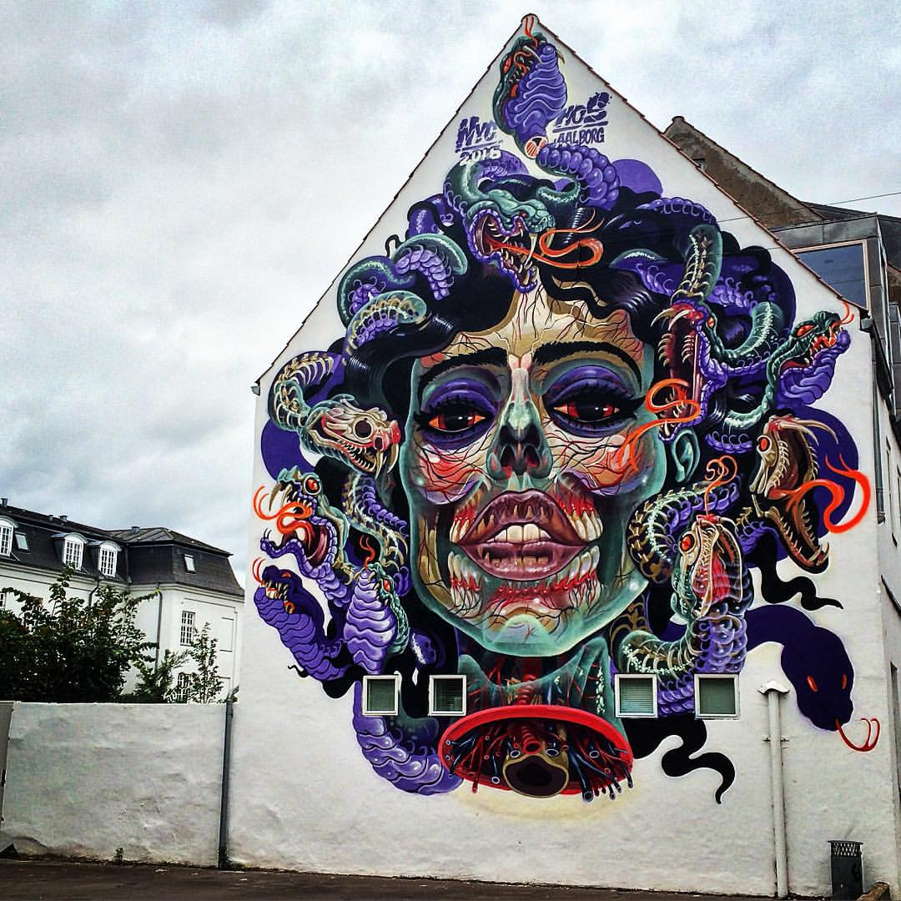
Significant artwork
Name: Translucent Medusa
Date: October 3rd 2015
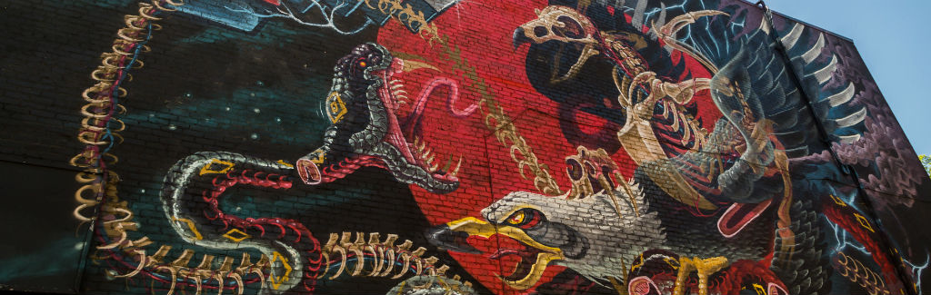
“Translucsent Medusa” is one of Nychos’ newest murals. Painted in Aalborg, Denmark on a WEEART wall (Urban Art festival in Denmark). The painting depicts a picture of an x-ray of medusa. The mural is filled with dynamic techniques in order for the viewer to find it hard to “escape Medusa’s petrifying gaze.”

Name: Screaming for Vengeance
Date: June 20 2015
This art piece is homage to Nychos’ love for heavy metal as it refers to Doug Johnson’s album cover for a British heavy metal band, Judas Priest. Nychos changes the original metal as seen on the album cover into an actual animal. The eagles body and skeleton are working separately together when fighting against the snake. The artist chose to make these elements work separately while adding in his signature translucent effects in order to create aesthetics that would make viewers “skin crawl”. This mural shows the artists distinct art style and technicality.

Questions:
- What makes his art style so distinct from other graffiti
- What was his reason for creating the “Rabbit Eye Movement” art group in 2005?

