Nadir Afonso
Yuliya Bezpalko
AVI4M

Biography
December 4, 1920 – December 11, 2013.
Nadir Afonso was a geometric abstractionist painter born in Chaves, Portugal. Nadir studied at the School of Fine Arts in Porto, Portugal, however, he later rejected architecture as art, stating that it was science instead. He formally trained in architecture, which he practiced early in his career with Le Corbusier and Oscar Niemeyer. While working under Le Corbusier in Paris until 1984, he gradually developed his own style of geometric abstractionism. Nadir believed that “art is purely objective and ruled by laws that treat art not as an act of imagination, but of observation, perception, and form manipulation.” Afonso graduated in architecture, even though he flunked the third year because some of his professors did not accept his artistic style. He then settled in Porto and started to design houses and industrial buildings, while at the same time painting the city around him under his other surname, Rodrigues. Throughout his lifetime, he achieved great honours, representing his country, at the finest level. He produced many paintings and serigraphs (screen printing). His preferred materials were acrylic paint on canvas, which were his bigger works, and gouache on paper, which were his smaller works, often used as studies for bigger works later on. By the age of 4, he created his first painting on a wall at home: a perfect red circle which anticipated his life under signs of rhythm and and geometric precision. Later on, by the age of 50, he was well known and regularly exhibited in New York and Paris. Nadir has published several books proving his theory of geometry-based aesthetics. In 2010, there was an exhibition of his work entitled "Nadir Afonso Sem Limites" in several museums in Portugal.

Art Movements
Geometric Abstraction- Geometric abstraction is a form of abstract art based on the use of geometric forms sometimes, though not always, placed in non-illusionistic space and combined into non-objective compositions.
Contemporary art- Art produced at the present period in time. Includes, and develops from, Postmodern art, which is itself a successor to Modern art.
Modern art- Includes artistic works produced during the period extending roughly from the 1860s to the 1970s, and denotes the style and philosophy of the art produced during that era.
Op art- Also known as optical art, is a style of visual art that uses optical illusions. Op art works are abstract, with many better known pieces created in black and white.

Significant Artworks
Nadir Afonso’s best-known and most distinctive work is the “Cities” series, each painting usually representing cities from all around the world.
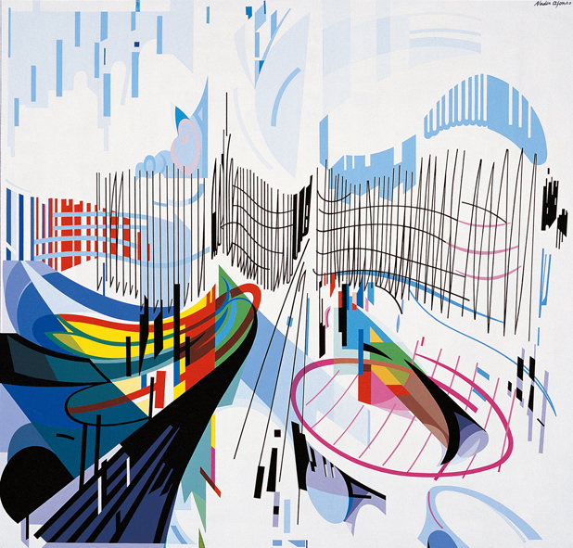
Nadir Afonso, Munich, Germany, Gouache on paper, 26.5 x 28.3cm

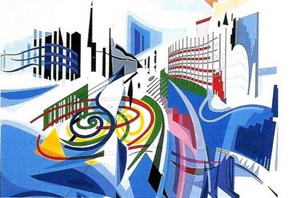
Moscow, 1995. A colorful period in the Cities series, even though Nadir Afonso declares that color is secondary and an afterthought.

Questions:
1. Explain Geometric Abstraction and how it was used in Nadir Afonso’s art.
2. What was Nadir Afonso’s reasoning for why he rejected art?

