Pop Art

Pop Art was a movement that started in the mid 1950’s and lasted all the way to the 1970’s. It first started in Britain, and is a direct descendant from Dadaism with its notion to mock what was previously considered art, the way it goes directly against what was considered traditional ‘High art’. Pop art focuses mainly on the attitude and reasoning behind the art rather than the art itself. While much of art up until then was meant to look beautiful, original and anything of the sort. Traditional high art was based on themes such as history and mythology, so in retaliation to that mindset, pop art was created as something that mimics and relates to popular, modern culture, moving directly away from traditional art. It focuses on commonplace objects and media as well as common people. The idea of pop art was to make it easily identifiable to the public. This was done by using industrial objects, brand logos and famous people as key elements to every piece.   
For example, Andy Warhol constantly used common objects and popular actors such as Campbell’s soup cans and Marilyn Monroe in many of his pieces.   
Each of the three artists Ed Ruscha, Takashi Murakami and Roy Lichtenstein have contributed to pop culture, all the way from when it started to today.

Ed Ruscha

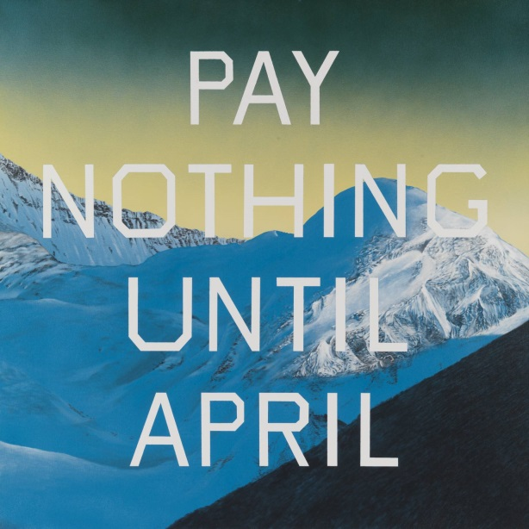

Ed Ruscha’s art training was centred mostly on commerce, so many of his pieces included text as the focal point. While he has worked with surrealism and Dada, he is most famous for his large number of text pieces. He uses common phrases and words that belong to daily life in L.A., which is where he lives. He has said that sometimes he would even use phrases that h hears people say on the street and will even use a dictionary to make sentences on his own. In this way, he is taking common life and turning it into works of art using photography and painting, going against the traditional standards of art.

In this piece (Pay Nothing Until April), You see a natural, serene background with the phrase “PAY NOTHING UNTIL APRIL” on it, which sounds much like an advertisement.

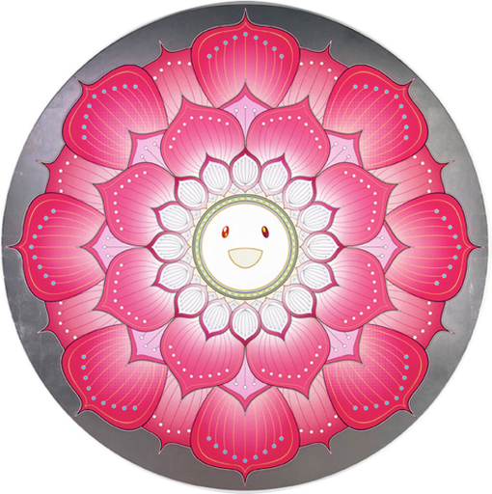

Takashi Murakami is known as the ‘Warhol of Japan’ because his art mainly focuses on modern Japanese culture. Many of his works consist of bright graphics based off of anime and cartoons, a heavy impact in Japan’s culture today. In fact, Superflat, a term that he uses to describe his own style as well as many of his pieces, is based off of the style of traditional Japanese art but also of how it has been brought through the ages into anime and manga today. Takashi himself also believes that it was inevitable that art is mixed with commerce, and finds the thought of traditional art being on a higher tier ‘rigid’.

‘Lotus Flower’ (2010), takes a symbol of purity and virtue in different religions including Buddhism and Hinduism, and put a cute cartoonish face on it, similar to the style of anime.

Takashi Murakami

Roy Lichtenstein

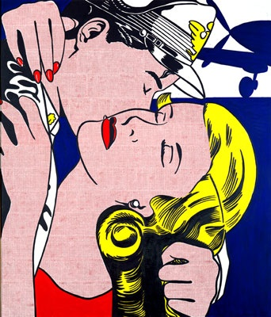

Roy Lichtenstein’s ‘The Kiss’ (1961) is not only made to look like a comic strip, but it is also directly quoting Gustav Klint’s ‘The Kiss’, a well-known classic painting made back in the 1900’s.

Roy Lichtenstein is well known for his contribution to the pop art movement. While his early work ranged greatly in style, in the 1960’s he began working on large comic-book style paintings. He focused on media that was popular and common at the time, it being comic books, and decided to portray them as high end art. While comic strips themselves were industrially made, he made sure to hand-paint all of the details and blew them up to a much larger size, much like traditional paintings were supposed to be. Not only did he blow up comic strips, he also redid famous paintings from other artists in a comic style to emphasize the idea of common object and styles becoming high art.

**Question 1**: What was the Pop Art movement trying to oppose/ridicule?  
Question 2: In their art, what is each of the three artists’ key characteristic? What was meant to stand out/be focused on in their pieces?