-- David Fincher --

Biography
- Fincher is a film director and producer
- Born on August 28th, 1962 (currently 53 years old) in Denver, Colorado
- He has been nominated for the Academy Award for Best Director twice, for “The Curious Case of Benjamin Button” and “The Social Network”
- He knew he wanted to go into filmmaking at a young age and started making movies when he was 8 years old
- He started his career directing commercials and music videos with such production companies as Industrial Light and Magic and Propaganda Films
- While mostly dealing with films he has also worked on a few television series, most notably House of Cards, for which he executive produces and directs

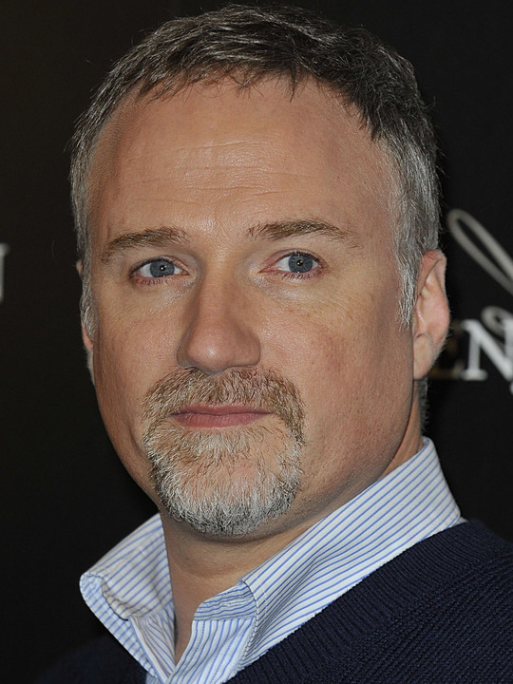
Filmography
- Gone Girl 2014
- The Girl with the Dragon Tattoo 2011
- The Social Network 2010
- The Curious Case of Benjamin Button 2008
- Zodiac 2007
- Panic Room 2002
- Fight Club 1999
- The Game 1997
- Se7en 1995
- Alien³ 1992

Filmmaking Techniques
- Strong focus on visuals
- Dark lighting and dark colour palettes
- Shadows and silhouettes are used to obstruct the faces of characters.
- Very long, always smooth, tracking shots used to show various perspectives of a location/scene.
- Inserting quick single frames that add additional context to scenes, likely a technique picked up from music video directing
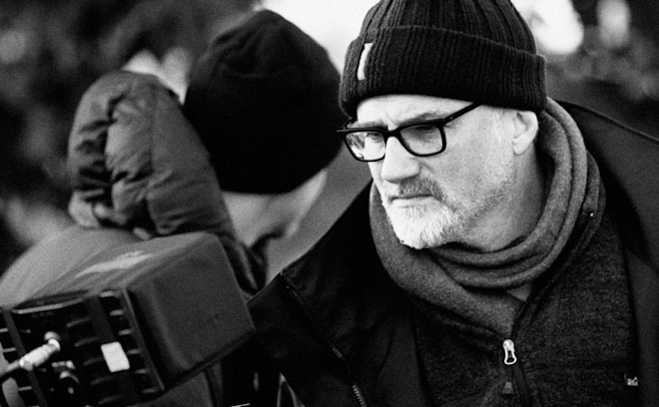

Known For
- Many of his films are psychological or mystery thrillers that involve a lot violence, which has led to much controversy over them
- Fincher’s films explore the darker side of humanity often including themes of obsession and the search for truth.
- His films are technically very well made with a lot of focus on the camera work, lighting, and clean cinematography
- He is a perfectionist and a meticulous director due to his attention to detail – he often calls for numerous takes of the same scene to get a perfect shot
- He wants to make viewers of his films "feel uncomfortable."
"Entertainment has to come hand in hand with a little bit of medicine. Some people go to the movies to be reminded that everything's okay. I don't make those kinds of movies." - Fincher

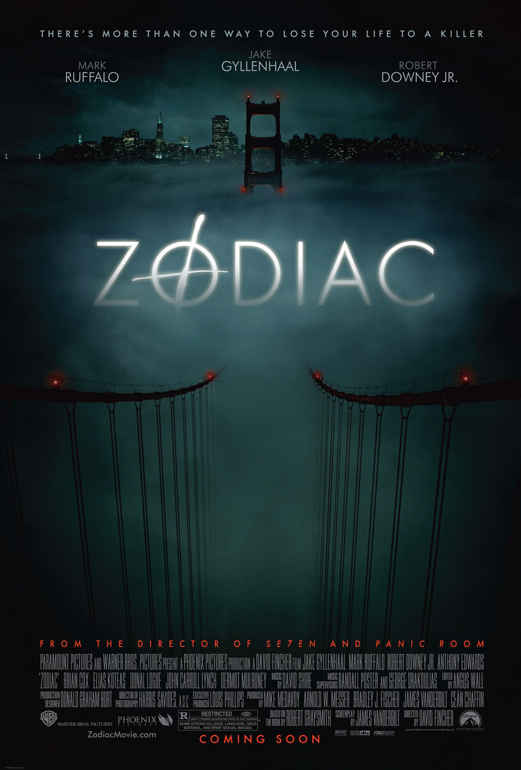

Significant Work
Despite how they may have been received at the box office many of Fincher’s films were critically acclaimed or have become cult classics. Many view Zodiac as his best crafted film. Based on real events, the film is about the search for a serial killer, called Zodiac, during the 60s and 70s in San Francisco. The combination of the increasing obsession of the investigators and reporters and Zodiac’s murders and cryptic messages make the film an extremely tense, dark thriller that keeps the audience with the story to its (inconclusive) ending.

Influences
Alfred Hitchcock, Martin Scorsese, George Roy Hill, Alan J. Pakula, Ridley Scott

(Some of) Fincher’s Favourite Films
- Lawrence of Arabia (1962) - The Terminator (1984)
- American Grafitti (1973) - Cabaret (1972)
- Citizen Kane (1941) - Dr. Strangelove (1964)
- The Godfather Part II (1974) - Jaws (1975)
- Mad Max 2 (1981) - Monty Python and the Holy Grail (1975)
- Taxi Driver (1976) - National Lampoon's Animal House (1978)
- Alien (1979) – the third film in the seriees was the first film he directed

Questions
- How does Fincher use his trademark techniques to create the mood of a film?
- What is one way that Fincher is different from other filmmakers?

Resources

Anderson, Kyle. "Directors Cuts: Top 7 David Fincher Films." Nerdist. 29 June 2015. Web. 27 Nov. 2015. <http://nerdist.com/directors-cuts-top-7-david-fincher-films/>.

Biography.com Editors. "David FIncher Biography." The Biography.com Website. A&E Networks Television. Web. 28 Nov. 2015.
<http://www.biography.com/people/david-fincher-411094#recent-work>.

"David FIncher." TSPDT. Web. 27 Nov. 2015. <http://www.theyshootpictures.com/fincherdavid.htm>.

O’Connell, Max. “The Films of David Fincher, Ranked from Worst to Best.” Indiewire. 30 Sept. 2014. Web. 25 Nov. 2015.
<http://www,indiewire.com/article/the-films-of-david-fincher-ranked-from-worst-to-best-20140930?page=2.

Perno, G.S. "Directors' Trademarks: David Fincher." Cinelinx. 1 Oct. 2014. Web. 24 Nov. 2015. <http://www.cinelinx.com/movie-stuff/item/6492-directors-trademarks-david-fincher.html>.

