Max Ernst

Biography
- Maximilian Maria Ernst- Born April 2nd, 1891 in Brühl Germany
- German self-taught painter and sculptor
- Leading advocate of irrationality in art and originator of the Automatism movement of Surrealism
- Early interests in psychiatry and philosophy but abandoned his studies at the University of Bonn for painting.
- He was a soldier in WWI deeply traumatized and this “fed” into his creation/vision of the modern world as irrational, which became the basis of his artwork.
- Majority of his life was spent in France during WWII and was categorized as an alien enemy even when he arrived in the US as a refugee
- In 1922 Ernst moved to Paris, where two years later he became a founding member of the Surrealists (a group of artists and writers whose work grew out of fantasies evoked from the unconscious.)
- In 1925 Ernst used techniques such as Frottage (pencil rubbings of things such as wood grain, fabric, or leaves) and Decalcomania (technique of transferring paint from one surface to another by pressing them together)
- 1929- Ernst returned to collage (artistic technique of applying manufactured, printed, or “found” materials, such as bits of newspaper, fabric, wallpaper, etc., to a panel or canvas, frequently in combination with painting) and created his first “collage novel”- a sequence of illustrations assembled from 19th and 20th century reading material.
- After 1934- Ernst’s activities centred increasingly on sculpture, using improvised techniques in this medium just as he had in painting.
- At the outbreak of World War II, Ernst moved to the United States, where he joined his third wife, the collector and gallery owner Peggy Guggenheim (divorced 1943), and his son, the American painter Jimmy Ernst.
- While living on Long Island, New York, and after 1946 in Sedona, Arizona (with his fourth wife, the American painter Dorothea Tanning), he concentrated on such sculptures as The King Playing with the Queen (1944), which shows African influence.
- After his return to France in 1953, his work became less experimental: he spent much time perfecting his modeling technique in traditional sculptural materials.
- Ernst remains a foundational figure for young Abstract Expressionists and artists deeply interested in technique, psychology, and desire to shock/confront social mores.

Dada and Surrealism
Dada -- was an art movement that formed during the first world in Zurich as a negative reaction to the horrors of the war. Art, poetry and performance produced by Dada artists is often “satirical and nonsensical” in nature. Dada artists felt their aim was to destroy traditional values in art and create new art. Dada was anti-bourgeois and had political affinities with the radical left. Founder of Dada was Hugo Ball

Surrealism – was the most influential avant-garde movement founded in Paris 1924 by a small group of writers/artists who sought to channel the unconscious to unlock the power of imagination. Influenced by Sigmund Freud, Surrealists believed the conscious mind repressed the power of imagination. Influenced also by Carl Marx, they hoped the psyche had the power to reveal the contradictions in the everyday world and spur on revolution. Surrealism + Frottage -- During the year in 1922, Ernst painted “A reunion of friends” which depicted his associates.
Key Ideas
- Attacked conventions of traditional art while possessing thorough knowledge of European history
- Questioned sanctity of art by creating non-representational works without clear narratives
- He made sport of religious icons and formulated new means of creating artworks to express modern condition
- He was profoundly interested in the art of mentally ill to access “primal emotion and unfettered creativity”
- One of the first artists to apply Sigmund Freud’s dream theories by investigating his deep psyche in order to explore his creativity, he also tapped into the universal unconscious with its common dream imagery. Because he was so interested in locating the origin of his own creativity, he attempted to paint from his inner psyche in attempt to reach a pre-verbal state of being, doing this helped him to unleash primal emotions/revealed personal traumas which became the subject of his collages/paintings.
Artworks
Here Everything is Still Floating (1920) The Elephant Celebes (1921)

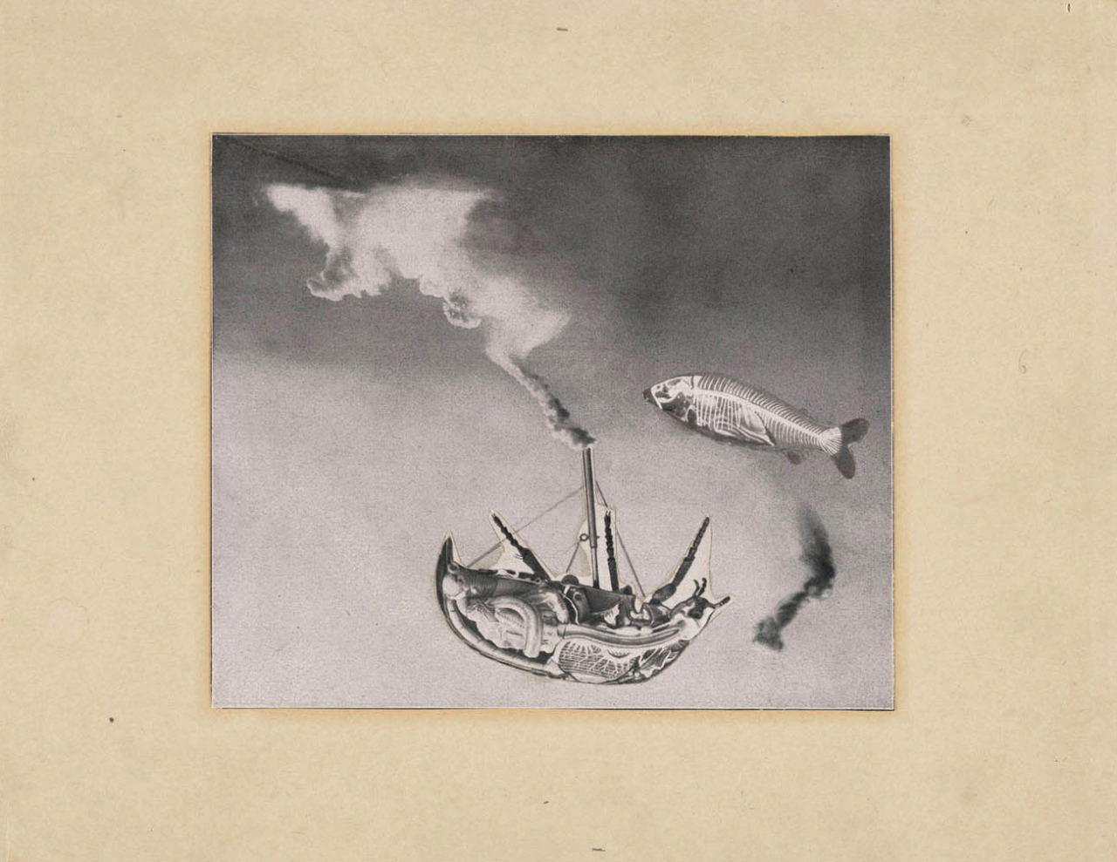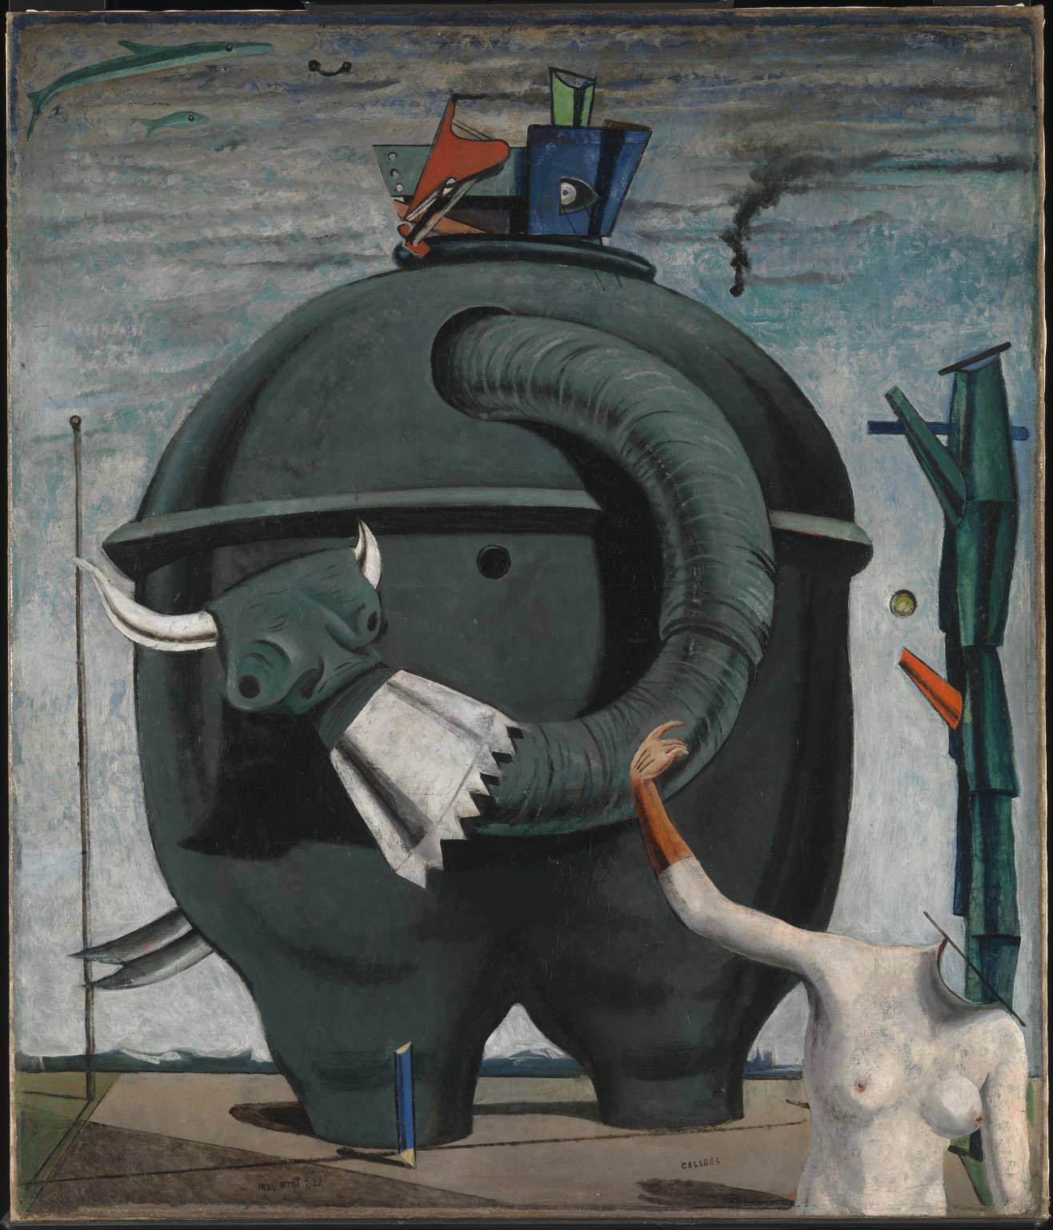
How did Sigmund Freud inspire many Surrealists?
What was the main objective of both Surrealism and Dada?

