Mark Molnar
Biography
- Concept Artist
- illustrator specialised on visual development and pre-production design for the entertainment industry
- Currently the Lead concept artist at Pixelloid Studios
- Works with digital media like photoshop or illustrator for creating his artworks.
- Provides different services such as creating character designs, environment designs,
- Had different clients from big companies like Universal, Square Enix, Legendary Pictures, and many others.
- Studied at Moholy-Nagi University of Art and Design & at the Concept Design Academy
- Published a digital artbook called Behind the Pixels which contains tutorials on his style
Works
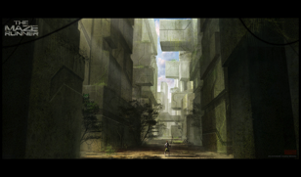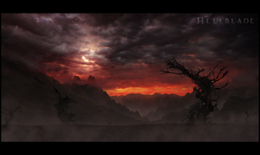
Maze Runner Hellblade
Video Game Art Creations
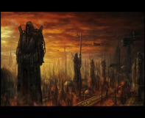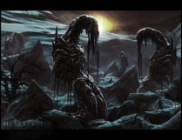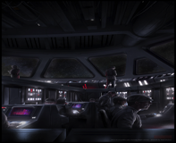
Warhammer 40k Hellblade Star Wars LCG

Mark Molnar creates concept designs for video game companies that are used for advertising their games or in some instances, for the actual game as some of the games he creates art for are card games. From his tutorials, he begins most of his works by identifying the main light source and working on from there.
Concept Art
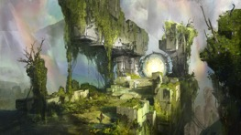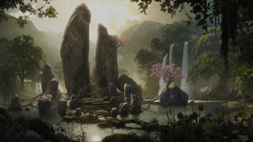
- A form of illustration used to convey an idea for use in films, video games, animation, comic books or other media before it is put into the final product.
- Also referred to as visual development and/or concept design
- Embraces the use of digital technology (prior to technology, they stuck to traditional mediums like pencil, paint, etc.)

Questions
What was the name of the book Mark Molnar published?
What is the purpose of concept art?
Resources
- http://markmolnar.com/
- http://www.behindthepixels.net/
- https://gumroad.com/markmolnar
- http://momarkmagic.blogspot.co.uk/

