KYSA JOHNSON
Significant artworks
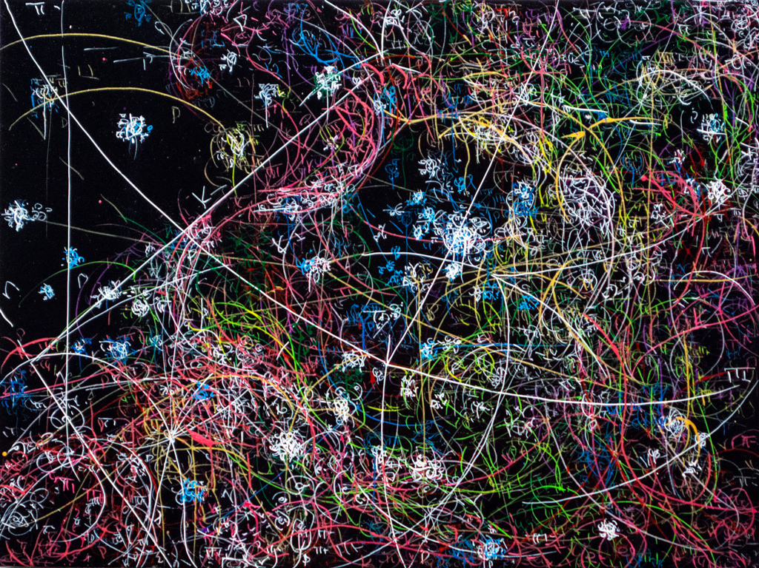
blow up 260 - the long goodbye (hello, hello) - subatomic decay patterns, 2015
Blow up 84- The asexual production of yeast- immaculate conception-2007
Johnson’s biographical information:
Johnson is a modern painter who was born in 1974. She went to school in Scotland, and she is currently living in New York. Johnson explores patterns in nature that are invisible to the naked eye. Johnson has had several gallery and museum exhibitions, and her most recent one is at the Morgan Lehman Gallery Johnson has been awarded with the New York Foundation for the Arts fellowship in 2003 with the Emmy Sachs Prize. Kysa Johnson was inspired by the painter/architect ‘El Greco’ from the Spanish Renaissance.
Art movements
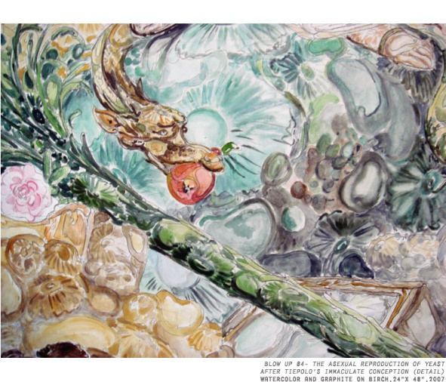
Johnson’s painting style explores patterns in nature that exist at the limits of scale. She uses the shapes of diseases and cures, maps of the universe, or the molecular structure of pollutants. It shows a physical reality that is invisible to the naked eye. For example; Johnson paints Virgin Mary by painting how bacteria and yeast look under a microscope.

2 Questions
- Who was Kysa Johnson inspired by?

2-What is Kysa Johnson’s painting style?
Resources
http://www.kysajohnson.com/
http://www.morganlehmangallery.com/artists/kysa-johnson
http://www.interviewmagazine.com/art/kysa-johnson-halsey-mckay/#_
https://www.artsy.net/artist/kysa-johnson

