JULIAN OPIE ILLUSTRATOR CHALLENGE
Julian Opie is one of the most significant artists of his generation, his distinctive formal language is the result of digital alteration, presenting images as black outlines and simplified areas of colour; it speaks of Minimal and Pop art, of billboard signs, classical portraiture and sculpture and Japanese woodblock prints. “Things in my experience don’t look photographic. When I recall the things I did in a day, for example, it’s not as a series of photographs, high resolution pictures. It’s a series of images which resemble symbols and signs. It’s like another language.” Opie ‘paints’ using a variety of media and technologies, from inkjet on canvas and painted aluminium to vinyl on walls and sculptures of everyday features: scaled-down buildings, life-size cars, signposts.
CHALLENGE
Use the same simplistic features that Opie uses to create a self-portrait with the pen tool. You can do this by tracing over the major features on a photograph.

You may need to take a new photo as most Opie portraits are a front view. Take and import a photograph straight from Photo Booth.
https://www.youtube.com/watch?v=N1mTXdScenQ
People Walking 2006 by Julian Opie - artwork outside Rogers headquarters in Toronto and at the AGO.
Opie created some controversy in the Henry Moore Sculpture Centre showing the Wallworks installation titled This is Shahnoza, 2006 vinyl - See more at: https://artmatters.ca/wp/2007/03/change-is-about-experimentation/#sthash.Afn1TzIH.dpuf

ADOBE ILLUSTRATOR PEN TOOL TUTORIAL
edited from a tutorial By Josh Grab https://joshuatgrab.wordpress.com/
TUTORIAL STARTS ON THE NEXT PAGE
OBJECTIVE: to learn how to use Adobe Illustrator’s most used tool, the Illustrator pen.
The pen tool in Illustrator functions by placing anchor points which define a path that eventually becomes an object. The anchor points define the path by controlling the angle of a corner, or shape of a curve. The tool itself is easy to use; however, it is difficult to master. The best way to learn this tool is simply by tracing shapes or objects within Adobe Illustrator as accurately as possible. When doing so it is best to have as few anchor points as possible to create a smooth high fidelity object.
When using the pen tool there are a number of features that are important to know. The pen tool can be used to place, add, subtract, and convert anchor points. Illustrator has built in easy commands to change the function of the pen tool. By pressing the “P” key you are able to use the basic function of the Pen tool which is to place anchor points to create an object. The “+” key allows you to add additional anchor points to an object to help create more detail as needed. The “-” allows you to remove excess anchor points as needed. Finally, the last feature is the Convert Anchor point tool. This tool can be used to change a normal anchor point to allow the designer to create a curve. This can be done by simultaneously pressing the “Shift” and “C” keys. This will change the cursor of the pen tool to a carrot. When an anchor point is converted using this function of the pen tool, two handles will appear allowing the designer to alter and change the curve so that it can be manipulated to whatever shape or form needed.
“P” – places anchor points
“+” – adds anchor points
“-” – subtracts anchor points
“Shift + C” – converts anchor points
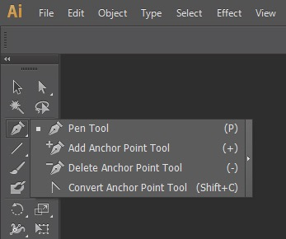
The photo shows where the Pen Tool can be located in Adobe Illustrator

The pen tool can place anchor points however you would like to arrange them, but sometimes it’s better to have as few anchor points as possible. For this reason the pen tool allows you to create curves by clicking and dragging in a single motion. The point you place will be a curve point – one which changes the nature of the path from straight (as with corner points) to curved. The lines which extend from these points are known as “Handles”. These Handles can be altered by using the direct selection tool (white pointer tool) which can be accessed by pressing “A”.

Now that you know the basics of the pen tool, it’s time for you to test your skills! A simple project to help you improve your pen tool skills is a Julian Opie project. Julian Opie is a modern artist who focuses on the simple features when creating portraits. 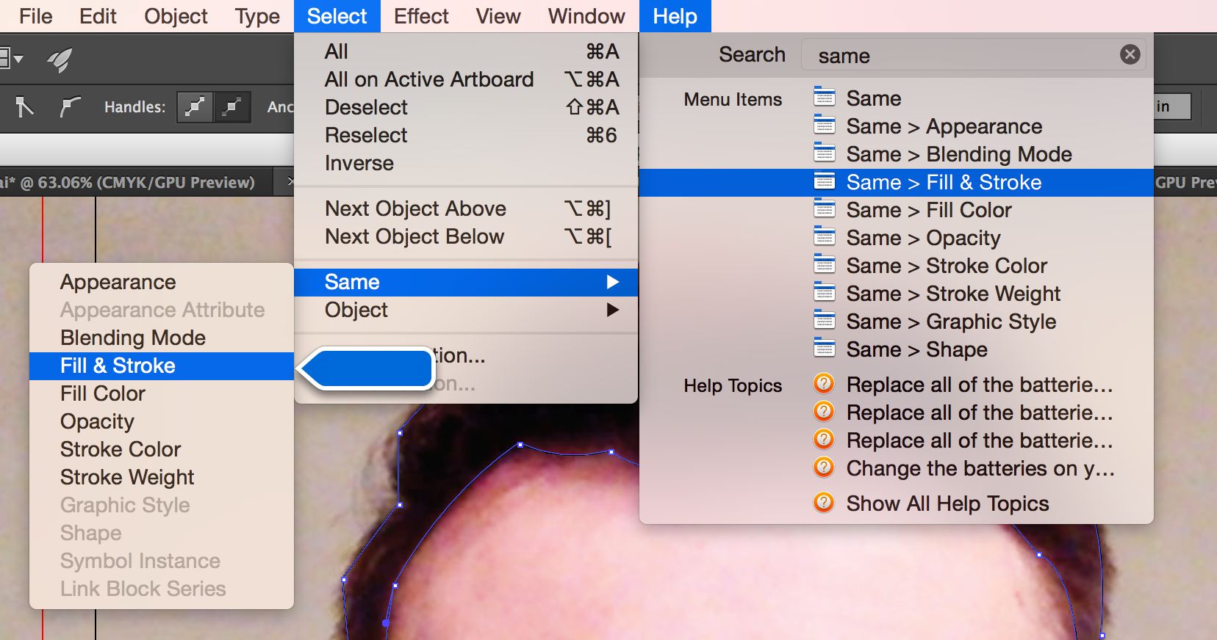
SUMMARY: easy to use, difficult to master.
- The pen tool in Illustrator functions by placing anchor points which define a path that eventually becomes an object.
- The pen tool in Illustrator functions by placing anchor points which define a path that eventually becomes an object.
- Use as few anchor points as possible to create a smooth high fidelity object.

“P” – places anchor points
“+” – adds anchor points
“-” – subtracts anchor points
“Shift + C” – converts anchor points: to change a normal anchor point to allow the designer to create a curve.

Once you have drawn a shape / object you can alter the thickness of the line (stroke) …
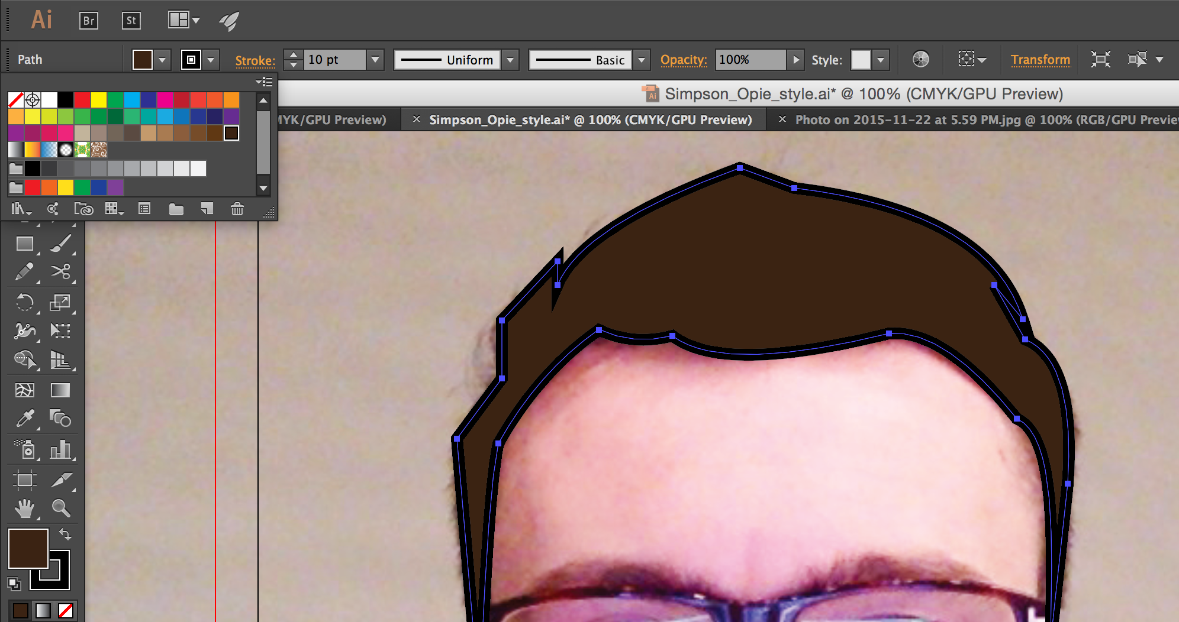… and colour of the shape (fill).

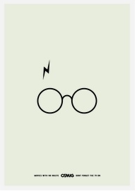
Work in progress
Minimalist Illustrator Portraits

https://www.webteam.net/blog/inspiring-minimalist-design

