Josephine Wall
by Luna Olexandro

Biography
- Fantasy painter and Sculptor. Painted all of her life, mainly loves working at home in her attic studio.
- Born in Farnham, Surrey in May 1947.
- Designed Delphis Ware while working at Poole Pottery
- Had her paintings exhibited in Tokyo and Tehran in 1974 and had a first solo exhibition in 1975 in Swindon.
- Continues to paint today, and has her own gallery in Penn Hill, Poole, Dorset, U.K.
- Her paintings have been printed on the postcards, calendars, and various items.

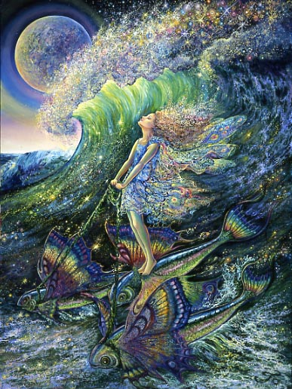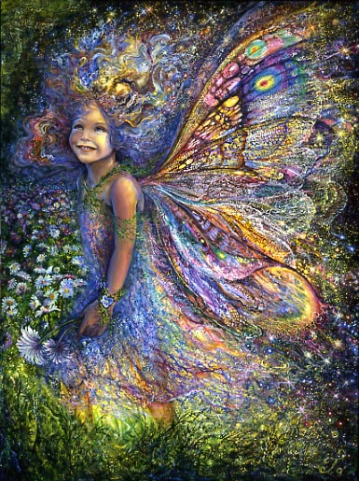
____________Surfer’s Dream______________________ _The Wood Fairy

Artworks

Josephine Wall paints magical artworks, mainly showing beautiful girls and women surrounded by flowers and fantasy - like environment. Fairies, Surrealism, Zodiak, and Goddesses are some of her art categories. She has hundreds of painting, as she has been painting her whole life. He most recognizable ones are perhaps The Surfer's Dream and The Wood Fairy, which have appeared on many postcards and various merchandize.

Style & Median

She uses bright colours, soft colours, and sometimes surprising colours such as blue highlights on skin. To create her bright paintings, she uses acrylic paint on canvas which allows her to complete them fast and execute various effects. Josephine Wall also created pottery works, figurines of mythological creatures and characters from Lord of the Rings.

Inspirations

The surrealism and fantasy illustration is what has inspired Josephine Wall’s paintings. Particularly, her art is inspired by the works of Arthur Rackham, Rene Magritte, and Salvador Dali. She also spent a lot of time being in nature, and shows her love for it in her paintings. Wall hopes that her magical paintings help to inspire other people to reach inside their own minds and open their own imagination.

Questions:

- What inspires Josephine Wall to create her works?
- What are the unique distinctions of her work?
http://www.josephinewall.co.uk/about_jo.html

