**Islamic Art**

Early Islamic Art Early Medieval Period Late Medieval Period

ninth century twelfth century fifteenth century

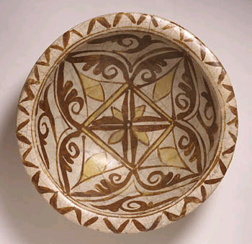 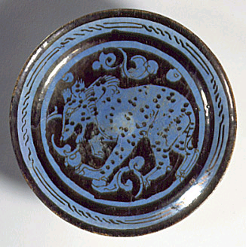 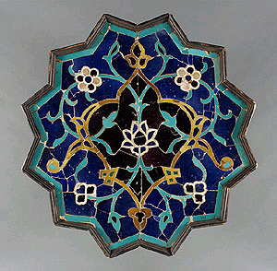

**Bowl Plate Tile**

Iraq Iran Greater Iran

Although the shapes and structures are based on the geometry of Euclid and other Greek mathematicians, Islamic artists used them to create visual statements about religious ideas. One explanation of this practice was that Mohammad had warned against the worship of idols; this prohibition was understood as a commandment against representation of human or animal forms.

Artists did not seek to express themselves, but rather, to create beautiful objects for everyone to enjoy.

**The Alhambra**

Style: Moorish (Islamic)

Granada in Spain

1338 to 1390



Once the residence of the Muslim rulers of Granada and their court, now one of Spain's most famous Islamic architecture and a major tourist attraction.

**M.C. Escher (1898 – 1972**)

Escher became mesmerized by the ‘Alhambra.

He studied the ornamentations with which the walls and floors were adorned and copied many of the motifs. These designs and motifs were the basis of his ‘spatial structure theme’ which explores ‘tessellation’ and negative and positive space.

From Ernst,B*., The Magic Mirror of M.C. Escher*, 1985

For more information:

<http://www.fountainmagazine.com/Issue/detail/The-Influence-of-Islamic-Art-on-MC-Escher>

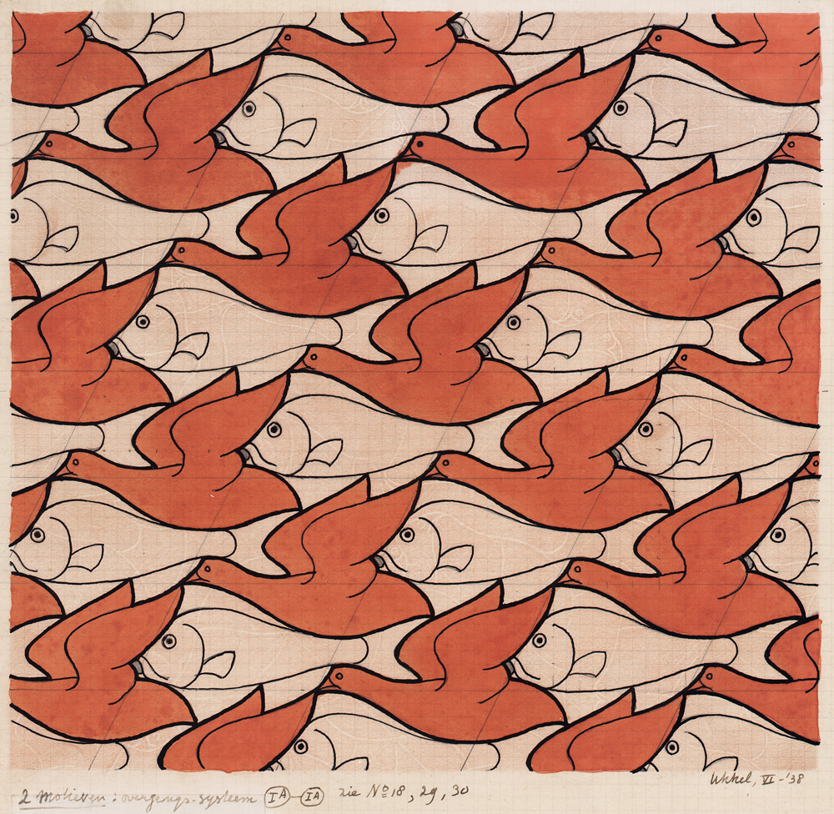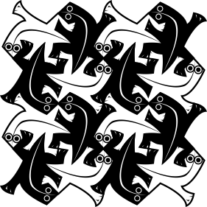

Bird/Fish, June 1938 *Creating patterns like Escher*

Drawing, 228 x 243 mm (9 x 9 5/8'')

<http://coreldraw.com/blogs/insider/archive/2010/03/22/article-creating-patterns-like-escher-part-2.aspx>

A **tessellation** or **tiling** of the plane is a collection of plane figures that fills the plane with no overlaps and no gaps. Tessellations frequently appeared in the art of M. C. Escher. Tessellations are seen throughout art history, from ancient architecture to modern art

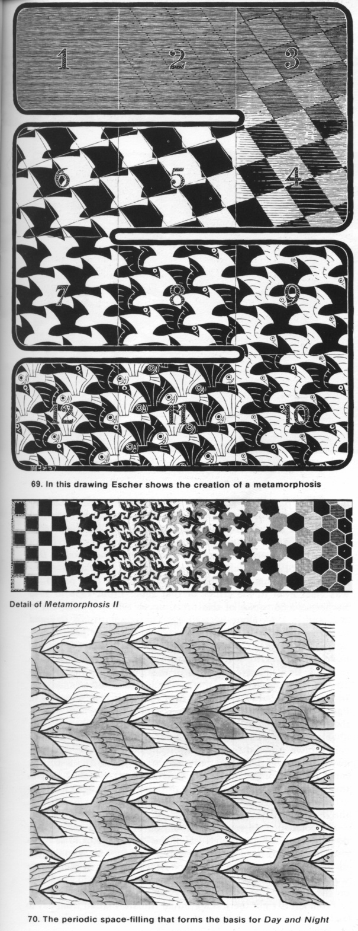

The picture on the left is a step by step drawing on how **Escher** created ‘Metamorphosis’. Notice the influence of Islamic pattern designs in his drawing.

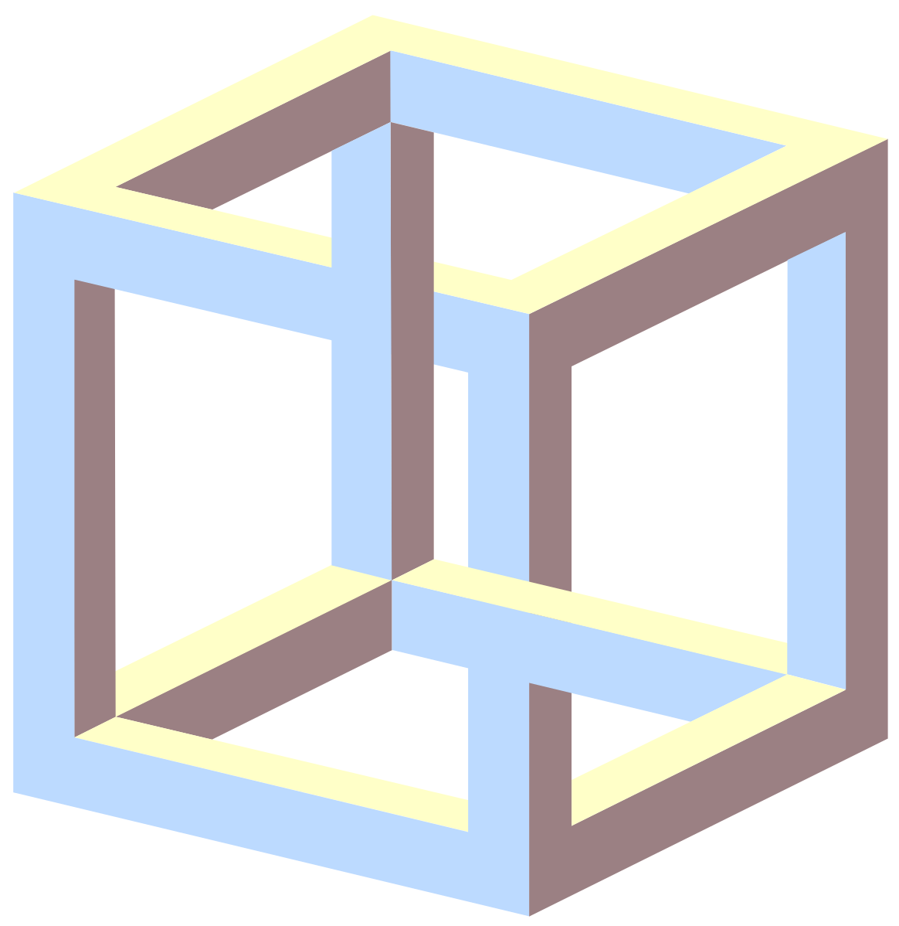

The **impossible cube** is an  [object](http://en.wikipedia.org/wiki/Impossible_object) invented by [M.C. Escher](http://en.wikipedia.org/wiki/M.C._Escher) for [*Belvedere*](http://en.wikipedia.org/wiki/Belvedere_(M._C._Escher)), a [lithograph](http://en.wikipedia.org/wiki/Lithograph) in which a boy seated at the foot of the building holding one.