2013-2014 FINAL EXAM SEMESTER 1
LESSON ONE: Ways of Seeing / Learnt Assumptions
LESSON TWO: Abstract Art & Formalism & Conceptual Art (modern culture / society)
LESSON THREE: Originality & Authenticity

PART 1: ARTISTS & ART MOVEMENTS
PART 2: Your Art: ISP and Coursework

http://www.youtube.com/watch?v=jl1zyCzQ_BQ
Jeff Koons: Money & Value | Art21 "Exclusive"
http://www.youtube.com/watch?v=MwZveNsRGiU
Jeff Koons en art21 (sub esp)
About the Artist
Jeff Koons plucks images and objects from popular culture, framing questions about taste and pleasure. His contextual sleight- of hand, which transforms banal items into sumptuous icons, takes on a psychological dimension through dramatic shifts in scale, spectacularly engineered surfaces, and subliminal allegories of animals, humans, and anthropomorphized objects. The subject
of art history is a constant undercurrent, whether Koons elevates kitschto the level of Classical art, produces photos in the manner of Baroque paintings, or develops public works that borrow techniques and elements of seventeenth-century French garden design. Organizing his own studio production in a manner that rivals that of a Renaissance workshop, Koons makes computer-assisted, handcrafted works that communicate through their meticulous attention to detail.

Teaching Connections:
Media and Materials: installation, painting, public art, sculpture
Key Words and Ideas: collaboration, fabrication, juxtaposition, kitsch, metaphor, popular culture
Related Artists: Paul McCarthy, Yinka Shonibare mbe, Doris Salcedo, Jessica Stockholder,
Iñigo Manglano-Ovalle
While Viewing: List all the references to popular culture that you recognize in Koons’s work.
After Viewing: Koons speaks about his desire for communication and interaction. How does his choice of media, materials, and subjects relate to his desire to communicate through his work?

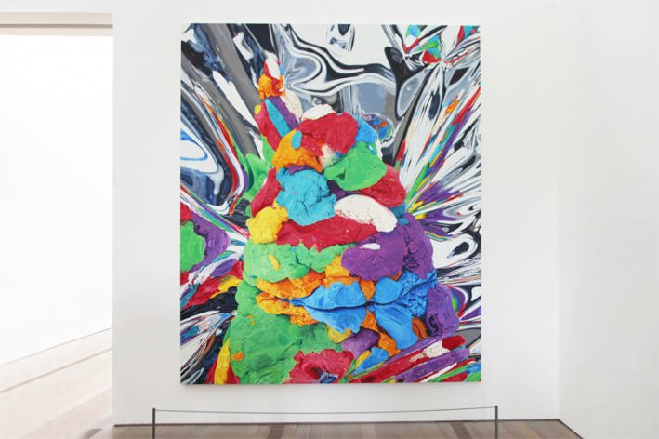
Play-Doh, 1995–2008. Oil on canvas, 131¼x 111¼inches. © Jeff Koons
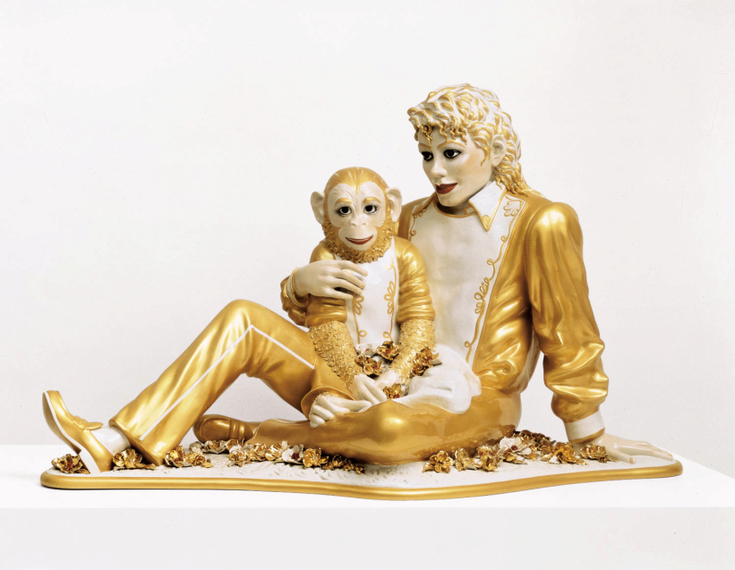
Michael Jackson and Bubbles,1988. Porcelain, 42x 70½x

PPT-Jeff Koons –includes Ways of Seeing/Learnt assumptions and questions

ARTISTS | MOVEMENTS / LABELS/CAREERS
Leonid Afremov, Salvador Dali, Gigi D.G., Jean Dubuffet, Theodor Seuss Geisel (Dr. Seuss), Jamie Hewlett, Ryoji Ikeda, Sarah Anne Johnson, Angie Jones, Lisa Keene, Chip Kidd, Jeff Koons, Louis and August Lumiere, Steve McCurry, George Méliès, Eadweard Muybridge, Victor Ngai, Claes Oldenburg, Mike Parsons, Mark Rothko, John Singer Sargent, Ralph Steadman, John Tenniel, Andy Warhol, Edison Yan, Zimoun, Lora Zombie | Activist, Abstract, Abstract Painting, Abstract Expressionism, American Renaissance, Animation, Art Brut, British pop culture, Comic, Contemporary, Contemporary Photography, Culture Jamming, Dada, Documentary Photography, Film, Gonzo, Graphic Design, Illustration, Installation, Modern impressionist, Noise Art /Sound Artist, Post Impressionism, Rococo, Pop Art, Post-Punk, Realism, Social Commentary, Street Art, Surrealism, Visual Development Art, War Photography

The most influential art of the 20th century
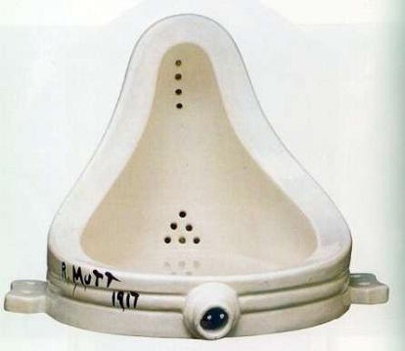
"Dada is the groundwork to abstract art and sound poetry, a starting point for performance art, a prelude to postmodernism, an influence on pop art, a celebration of antiart to be later embraced for anarcho-political uses in the 1960s and the movement that lay the foundation for Surrealism.”
Marc Lowenthal Translator's Introduction to Francis Picabia’s I AM A BEAUTIFUL MONSTER: Poetry, Prose, And Provocation (MIT PRESS 2007

Fountain, Marcel Duchamp
The Dada movement was started, during World War I, by a group of artists and writers in protest against the degradation of European society and the monstrous destruction of the war.

http://www.guardian.co.uk/arts/video/2008/feb/20/fountain.duchamp.tate

'Art that takes the piss out of the critic'

Duchamp_Bicycle_Wheel mp3 speaking of readymades “choices were made out of visual indifference.”
“…the idea/concept is the most important aspect of art.” Sol Le Witt

PPT (option) Found Object Art

Yinka Shonibare MBE
http://video.pbs.org/video/1281770054/
From the start - 15:30

Drawings started as a result of work around climate change
Objective things- takes things out of mag & newspapers and does intuitive things around that
“A juxtaposition of nature and culture”
Works collaboratively with an assistant
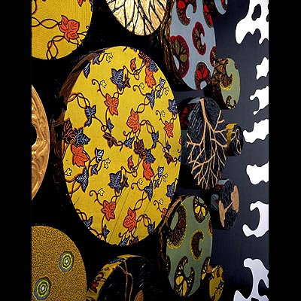
Yinka Shonibare MBE Black Gold I, 2006

- What was the motivation for Dada artists?
- What are the similarities with Yinka’s work? What was happening in 2006 to prompt this work?
http://environment.about.com/od/environmentalevents/a/2006_top_news.htm
http://www.federalreserveeducation.org/about-the-fed/history/2006andbeyond.cfm
Dada exploited the “mystique of accident” or “automatism” Yinka worked “inuituively”.

When we look at a work of art, we are affected by a whole series of learnt assumptions concerning:
Beauty, Truth, Genius, Civilization, Form, Status, Taste
In your opinion which of these is the most important when looking at Black Gold? (You may want to consider the subject matter, the material, influences, the viewer’s role...)

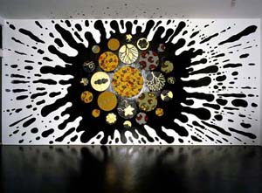

Snake Ceiling – On May 12, 2008, a massive earthquake in China’s Sichuan province killed approximately 90,000 people. Ai Weiwei created a serpentine sculpture titled Snake Ceiling, made of backpacks, to commemorate the more than 5,000 school children who were killed when their shoddily constructed schools collapsed.
Artistic Influences – Compare and contrast this artwork by Ai Weiwei with an artwork by Marcel Duchamp, an artist who influenced Ai through his use of ready-mades. What are the similarities and differences?

LESSON TWO: Abstract Art & Formalism & Conceptual Art (modern culture / society)

PPt- Post Modern Elements Short Version

Contemporary Art definition: Contemporary art is art produced at the present period in time. Contemporary art includes, and develops from, Postmodern art, which is itself a successor to Modern art. In vernacular English, "modern" and "contemporary" are synonyms, resulting in some conflation of the terms "modern art" and "contemporary art" by non-specialists.

Conceptual Art definition: art in which the idea presented by the artist is considered more important than the finished product, if there is one.

ARTISTS | MOVEMENTS / LABELS/CAREERS
Leonid Afremov, Salvador Dali, Gigi D.G., Jean Dubuffet, Theodor Seuss Geisel (Dr. Seuss), Jamie Hewlett, Ryoji Ikeda, Sarah Anne Johnson, Angie Jones, Lisa Keene, Chip Kidd, Jeff Koons, Louis and August Lumiere, Steve McCurry, George Méliès, Eadweard Muybridge, Victor Ngai, Claes Oldenburg, Mike Parsons, Mark Rothko, John Singer Sargent, Ralph Steadman, John Tenniel, Andy Warhol, Edison Yan, Zimoun, Lora Zombie | Activist, Abstract, Abstract Painting, Abstract Expressionism, American Renaissance, Animation, Art Brut, British pop culture, Comic, Contemporary, Contemporary Photography, Culture Jamming, Dada, Documentary Photography, Film, Gonzo, Graphic Design, Illustration, Installation, Modern impressionist, Noise Art /Sound Artist, Post Impressionism, Rococo, Pop Art, Post-Punk, Realism, Social Commentary, Street Art, Surrealism, Visual Development Art, War Photography

Concept is the most important aspect of art. Do you agree, reference other artists?
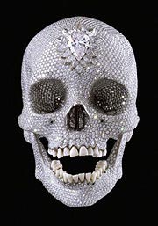

Title: For the Love of God, 2007
Materials: platinum, diamond, human teeth

What does this communicate about our culture/society?

For the love of God by Damien Hirst
http://www.youtube.com/watch?v=gejFvcASCzM
ArtPatrolTV | November 17, 2008 | 7 likes, 0 dislikes
Damien Hirst's skull / For the Love of God

“It [abstract art] should be enjoyed just as music is enjoyed – after a while you may like it or you may not.”

My Kid Could Paint That 40 mins today re: abstract expressionism / 40 minutes tomorrow re: authenticity

Powerpoint - Pollock painting & close up

Jean Dubuffet
His idealistic approach to aesthetics embraced so called "low art" and eschewed traditional standards of beauty in favor of what he believed to be a more authentic and humanistic approach to image-making.

what is Formalism? RE: Gary Michael Dault (cereal paintings) & Helen Frankenthaler
document- Frankenthaler ppt notes & questions
Powerpoint - dault frankenthaler grossman revision

Originality & Authenticity in art: What is your opinion
Start with Takashi Murakami

Is the art of Brian Jungen authentic?

