Catherine Dote
November 27, 2015
Artist Presentation. Information Sheet.
Abstract Expressionism Movement
- 1940's and 1950's, movement emerged during the post-World War II era in America where the "post-war mood of anxiety and trauma" was interpreted and expressed through abstraction.
- Influenced by the Surrealistic Movement where the art focused more on the human unconscious; "… the struggle between self-expression and the chaos of the unconscious."
- Many abstract expressionists were "avant-garde" towards the true meaning of what is or what should be considered as an art in this time period. Abstract expressionism relied on the manipulation of colors, lines, patterns, shape, and texture to create imagery devoid of any defining objects or figures; color fields, creation of abstract forms, paint splatters, movement in brush strokes.
- Large scale canvases were used as a means invoke emotional and psychological connection with the art and the artist; to fully grasp the artists expression through the vast abstract field of color, texture, forms. The person becomes completely engulfed in the art.
Abstract Expressionist: Clyfford Still. 1904-1980
- Born in Grandin, North Dakota. Through his childhood he lived in Spokane, Washington and Bow Island in southern Alberta, Canada. It has been said that many of his works were influenced by the flat fields and landscape of the Canadian prairie but Still never acknowledged claim.
- Studied painting, literature, and philosophy at Spokane University, graduated in 1933. In 1935, obtained a Masters in Fine Arts from Washington State College and taught for several years: " … He turned a younger generation away from the social realism of the 20th century and toward gestural abstraction" (sfmoma.org)
- By mid-1940's, his motif progressed away from representational art and towards the abstract, "non-representational" art and became associated with and recognized as a fellow contemporary in the Abstract Expressionism Movement.
- He painted on raw canvas, prepared his own pigments, using both palette knife and brush for application, linseed oil to achieve gloss. His signature works consisted of "jagged-edged fields of pigment, heavily applied and worked into a thick surface." (sfmoma.org)

Significant Artworks of Clyfford Still
"1944-N No. 2" "1948-C" "1957-J No. 2"
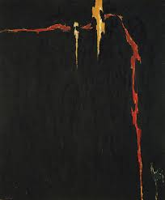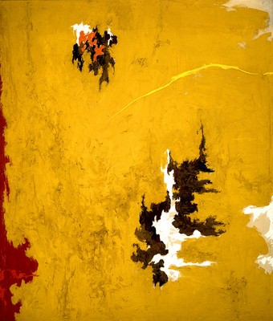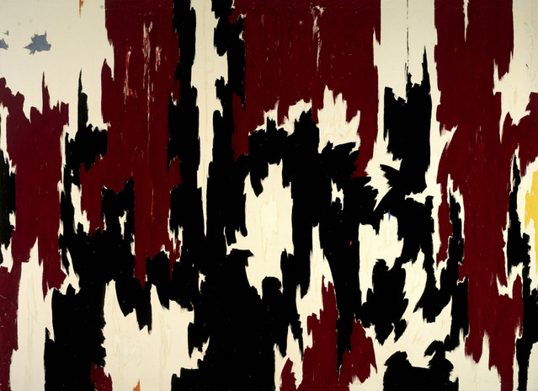

Question:
- In what ways is abstract expressionism influenced by the surrealistic movement?
- Why are large scale canvases significant to the abstract expressionistic approach to this art movement?

clyffordstillmuseum.org/clyffordstill/
smithsonionmag.com/arts-culture/clyfford-stills-sublime-art-89691/
theartstory.org/artist-still-clyfford-htm
sfmoma.org/artist/Clyfford_Still

