Character Design

By: Xinyang Wang

Character design is one of the most important processes in making an animation. It shows characters’ external forms, such as makeup, clothing and hairstyle; and personality, such as temperament, manner and behavior. Character design is like choosing actors in a live-action movie. The difference is responsibility of designers don’t need to shot actors in the film. They use brush to shape a character and give him life and feelings.
Hayao Miyazaki is a famous Japanese film director, producer, screenwriter， animator, author and manga artist. He directs and writes sprit for Spirited Away, his most representative anime film, by one person. It’s a story about a girl accidentally stepped into a spirit world. She takes a job working in bathhouse and finds a way to free herself and get back to human world. Miyazaki designs a lively heroine, Chihiro. She is and innocent, cute and naïve girl. As the story unfolds, she becomes brave and tough.

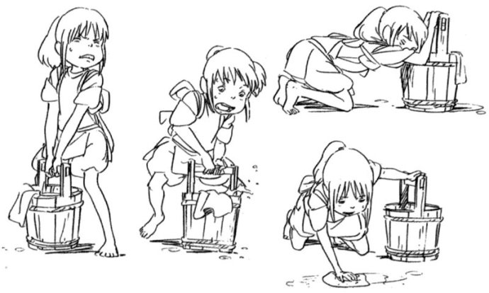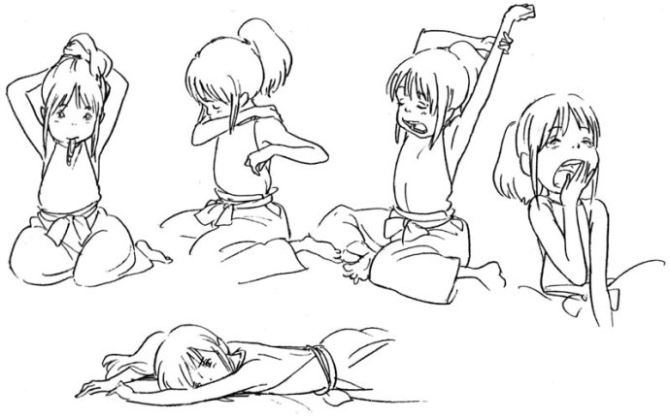
Spirited Away，2001，character design by Hayao Miyazaki

Questions

1.What does Neal (my original character) look like？ What sort of man is he? Use your imagination here.

——————————————————————————————————————————————————————————————————————

2. What do you think the elements of a successful character like Chihiro?

_______________________________________________________________________________________________

Bibliographies
http://characterdesign.blogspot.ca/
https://en.wikipedia.org/wiki/Spirited_Away
https://en.wikipedia.org/wiki/Hayao_Miyazaki

