BRUCE NAUMAN
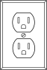
Is an influential provocative and innovative conceptual artist of the 20th century. that is known for exploring life in gory detail. After graduating he was struck with the question “what to do?” and realised “If I was an artist and I was in the studio, then whatever I was doing in the studio must be art. At this point art became more of an activity and less of a product.” Nauman was focused on the development of his style and the process in which his art was made. His work is not easily defined by its materials, styles, or themes and combines many themes to contribute to the Post-Minimalism, Process Art and Performance Art movements. Nauman considered drawings essential to the working process and integral for development of projects.
MEDIUMS INFLUENCES EXPLORE
-sculpture - Samuel Becket -Nuance of syntax (language, text, gesture)
-video - Ludwig Wittgenstein - spatial compositions
-film - Phillip Glass perception, physical/mental activity
-printmaking - John Cage linguistic manipulation, body awareness
-performance - La Monte Young - human body in environment
BIOGRAPHY
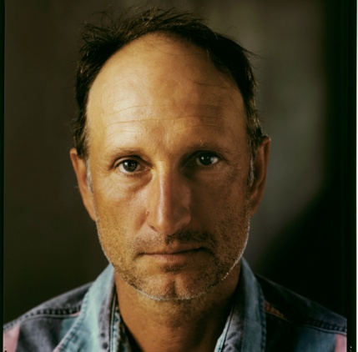
Bruce Nauman was born in Fort Wayne, Indiana on December 6, 1941. Nauman’s father was a salesman that moved the family to different mid western locations. This caused his childhood to be unstable. As a child Nauman took up music and studied the piano, guitar, and upright bass. He had no training and little exposure to art until his early college career where he developed a true passion for creating. Originally in the University of Wisconsin for physics he switched to the arts program and graduated with a BFA in 1964 and a MFA in 1966 from the University of California.

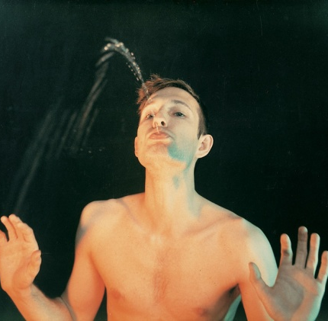
SELF PORTRAIT AS A FOUNTAIN -1966
The above Photo depicts one of Naumans 11 photgraphs based on puns. Here he questions the role of an artist showing the artist and work become one and the same. He mimics a nude statue customarily found in decorative fountains. This work makes fun of the artist as a genius who spews out masterpieces in a subtle stream. He references Marcel Duchamps fountain exhibit and tests conventional definitions of what a work of art is.

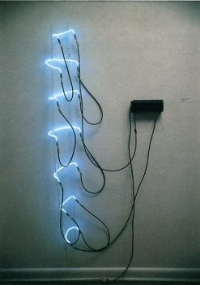
NEON TEMPLATES OF LEFT HALF OF MY BODY, TAKEN AT 10 INCH INTERVALS – 1966
Part of Naumans early work and the beginning of Naumans most recognized style. Here he explores neon work and the effect it has on the audience. This piece is related to his interest in anti form artworks. It is an unconventional self-portrait as it shows the contours of the artist’s body molded from neon tubes. Since its creation in 1966, Neon Templates has been exhibited in eighteen exhibitions and displayed in more than forty-five national and international venues.

TOPICAL GARDENS -2009
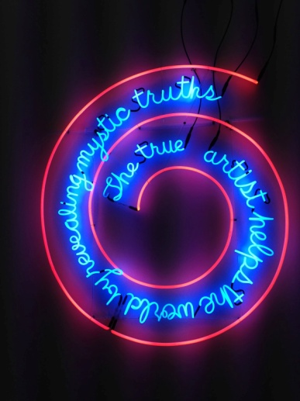
This exhibit was a showing of Nauman’s life’s work. It was at the 53rd La Biennale Di Venezia, the largest contemporary art exhibition in the world located in Venice. It is made of 30 pavilions each owned and operated by a different country. Nauman won the award for best national participation. In the exhibit, Nauman displayed his most popular art piece.

THE TRUE ARTIST HELPS THE WORLD BY REVEALING MYSTIC TRUTHS-1967

This work was created in an abandoned grocery store that Nauman converted to a studio. He was inspired by the neon signs in his environment and created an unconventional satirical advertisement. He contrasts the speaking of high art with the materials of low culture. It questions the purpose of art and artists. Are artists just salesmen of a different nature?

QUESTIONS
- What is considered to be Bruce Nauman’s most innovative style and what art movements is this sculpture apart of?

- Compare Bruce Nauman and Marcel Duchamp using one artwork per artist.

