“Beatrix Potter is one of the world's best-loved children's authors and illustrators. She wrote the majority of the twenty-three Original Peter Rabbit Books between 1901 and 1913. The Tale of Peter Rabbit is her most famous and best-loved tale.”
Birth: Helen Beatrix Potter was born on July 28, 1866 at 2 Bolton Gardens in Kensington, London.
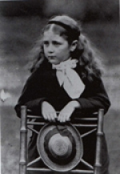
Childhood: Beatrix was born into a wealthy Victorian family, with both parents living off of inheritances from the cotton trade. Her parents lived a wealthy lifestyle, both spending their past time amongst writers, artists, and politicians. Beatrix’s parents both shared an appreciation for art. Her father, although a qualified barrister, practiced photography. Her mother was a watercolourist and skilled embroiderer. Her family was comprised of many other practitioners of art, such as her grandfather who was the co-founder and president of the Manchester school of Design, and her brother Walter Bertram Potter who was a talented painter. Many of these factors sparked the beginning of Beatrix’s pursuit of art.
Beatrix lived a very lonely childhood, she would often see her parents only at bedtime. She was raised and looked after by her nanny as well as the rest of the servants of the house. When she was old enough to start schooling, she continued to stay at home and was taught by a governess (children of her social class often did not attend school). She didn’t have many opportunities to see other children and make friends, therefore Beatrix and her brother became great playmates. Beatrix and her brother shared a love for animals, drawing the many pets they owned such as rabbits, mice, a tortoise, salamanders, frogs, hedgehogs, lizards, snakes, snails and a bat.
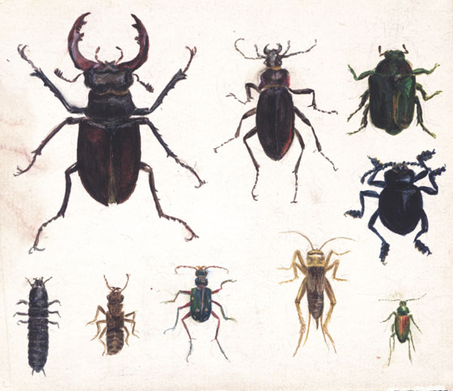
Education: In 1885 Beatrix began taking drawing lessons at the National Art Training School in order to get her Second Grade Art Student certificate. Beatrix practiced still life, exercises in design, and perspective. Beatrix received her certificate at the age of 21, but still remained home after because she lacked a “real education”. With time on her hands Beatrix continued studying on her own, taking an interest in the natural sciences. She studied various plants and animals at the Cromwell Road Museum, and drew scientific illustrations in great detail by examining the specimen under a microscope. Beatrix predominantly studied different types of fungi and wrote a scientific paper called “On the Germination of the Spores of Agaricineae”. With the assistance and support of her uncle, chemist Sir Henry Roscoe, her paper was presented to the Linnean Society to be published. Unfortunately due to the gender stigma of the time, her paper wasn’t taken seriously and was rejected in terms of its legitimacy.
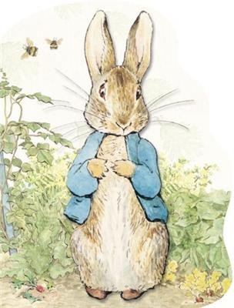
The Tale of Peter Rabbit: Beatrix began to focus on drawing and painting again, making some income illustrating for companies and selling paintings. In her past time she would send letters to the children of one of her former governess, Annie Moore, which contained illustrations telling The Tale of Peter Rabbit for the very first time. Beatrix began her letter “I don't know what to write to you, so I shall tell you a story about four little rabbits, whose names were Flopsy, Mopsy, Cottontail, and Peter”. Several years later Beatrix asked to borrow the letters, and she began making sketches for the rough draft of her very first children’s book. She wanted the book to be small so it could easily be held by children, and have black and white illustrations- the cheaper the better. Her book was rejected by six different publishers including Frederick Warne, because they wanted a book with an expensive format (coloured illustrations). But Beatrix was determined to keep the book as cheap as possible for “little rabbits cannot afford to spend 6 shillings on one book”. Finally in 1901 Strangeways & Sons printed 250 copies of The Tale of Peter Rabbit, and it was a huge success. Because the sales of the first edition did so well, Frederick Warne reconsidered publishing Beatrix’s book on the terms that the book was to be revised and printed in colour. The Tale of Peter Rabbit is now widely known as a popular children’s book, selling over 40 million copies worldwide.
The Real Peter Rabbit: In fact Beatrix did have a pet rabbit named Peter Piper, which she bought in 1893 due to the death of her other rabbit Benjamin Bouncer. Beatrix described Peter as an affectionate companion but very mischievous, making him the ideal character for a children’s book.
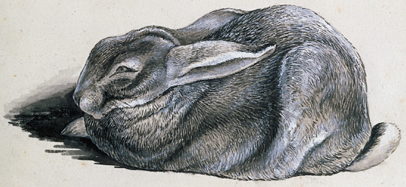
'Peter used to lie before the fire on the heart rug like a cat. He was clever at learning tricks, he used to jump through a hoop, and ring a bell, and play the tambourine.'

Death: December 22, 1943, Near and Far Sawrey, United Kingdom; Aged 77.

Question #1: What is Beatrix Potter most famously known for?
_______________________________________________________
Question #2: What artistic styles/techniques did Beatrix do?
_______________________________________________________
Works Cited
"Beatrix Potter." , The Extraordinary Life of a Victorian Genius. Frederick Warne & Co., n.d. Web. 07 Dec. 2015. <http://www.bpotter.com/Beatrix.aspx>.
"The Beatrix Potter Society: Aspects of Beatrix Potter's Life and Work." Beatrix Potter. The Beatrix Potter Society, n.d. Web. 07 Dec. 2015. <http://beatrixpottersociety.org.uk/>.
"Peter Rabbit." Welcome to the Official Website of Peter Rabbit™. Frederick Warne & Co, n.d. Web. 07 Dec. 2015. <http://www.peterrabbit.com/en>.
"Victoria and Albert Museum." Biography of Beatrix Potter. N.p., n.d. Web. 07 Dec. 2015. <http://www.vam.ac.uk/content/articles/b/biography-beatrix-potter/>.

