Barbara Kruger
Biography

- Born January 26 1945 in
Newark, New Jersey
- Left in 1964 to attend Syracuse University
- She developed many interests early on, some including: graphic design, poetry, writing and attending poetry readings.
- Spent a year at Syracuse University then moved to New York
- In NY she began attending Parsons School of design in 1965
- In 1966 she left school again and went to work at Condé Nast Publications
- Very short after she started to work at Mademoiselle Magazine as an entry level designer
- Shortly she got promoted to head designer
- Later she still did graphic design along with magazine layouts, book jacket designs, and photo editing for other publishers.
- In 1977, she took photographs combining architectural exteriors and her own text
- By 1979 she stopped taking photography and started incorporating other photography she found in magazines, with her text

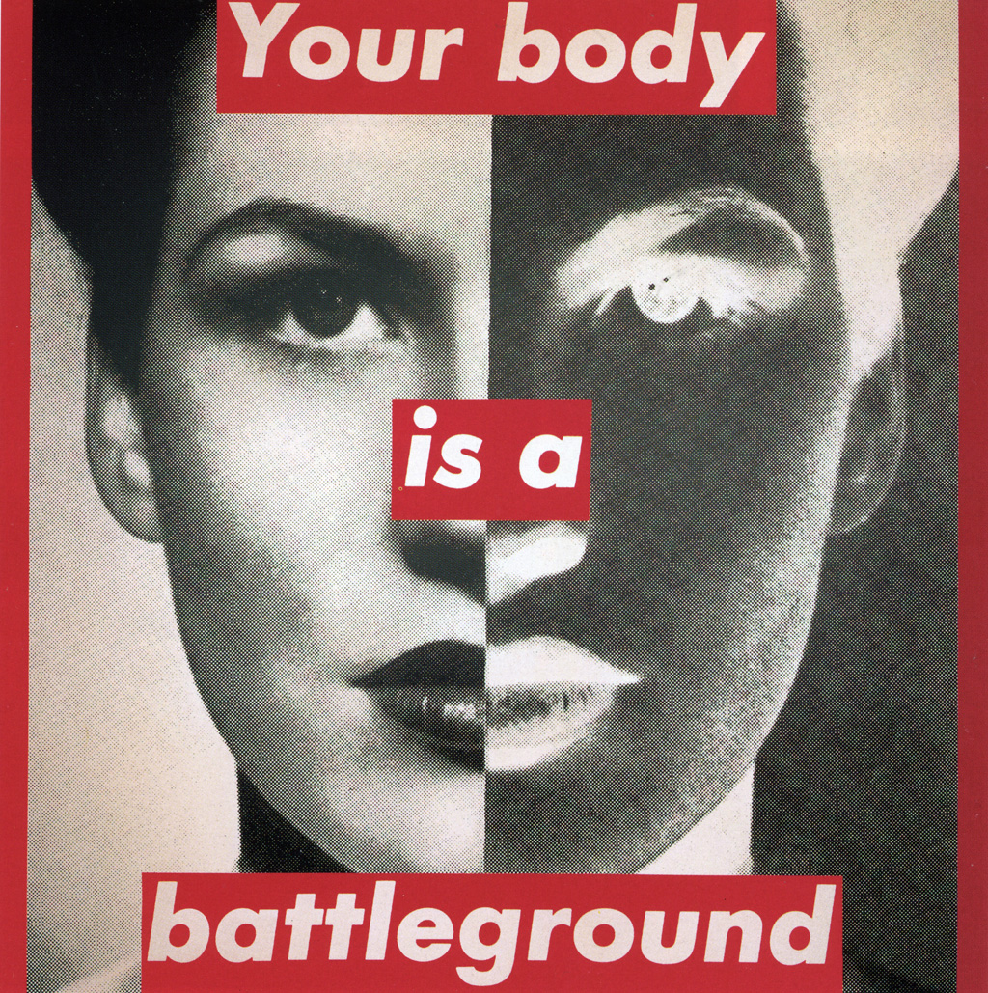
Untitled (Your Body Is A Battleground) 1985

Influences
- Kruger was a femisims artist
- Her text commented on religion, sex, gender and racial stereotypes, consumerism, corporate greed, and power
- i.e I shop therefore I am (on the right of this) points out that shopping is never as fulfilling as magazines make it out to be
- Her work, in a different form, was used to promote sales for Selfridges (department store) for a while
- And My Body Is A Battleground on the front side was used for the 1989 reproductive rights protest, the March for Women’s Lives
- The picture is split in half showing the photos positive and negative side
- This parallels with the inner struggles of good versus evil

Untitled (I shop therefore I am) 1987

Questions
- How does Kruger get her photographs?
- What does she like to make her text about?
Untitled (Pro-life for the unborn, Pro- death for the born) 2004
Bibliography

- http://imageobjecttext.com/2012/03/22/selling-a-message/
- http://www.arthistoryarchive.com/arthistory/feminist/Barbara-Kruger.html
- https://www.artsy.net/artist/barbara-kruger?period=2010
- http://www.theartstory.org/artist-kruger-barbara-artworks.htm#pnt_6

