William Lyon Mackenzie C.I. AVI4M
GRADE 10/11 VISUAL ARTS
CULMINATING ACTIVITY: APPROPRIATION

OBJECTIVE: Create a large acrylic panel painting combining natural and artificial/man-made imagery. They must have a relationship between each other or you can suggest one. Creative juxtaposition/ composition is crucial. MAKE CONNECTIONS.

MEDIA (options):  Acrylic Paint  Sharpie / Markers  Paint Pens  Spray Paint (stencils)  Ink  Printmaking  Gel Transfer | POSTMODERN ART APPROACHES:  - APPROPRIATION  - JUXTAPOSITION  - RECONTEXTUALIZATION  To place (as a literary or artistic work) in a different context  - HYBRID  - (LAYERING)
SURFACE  - Wood | SUGGESTIONS:  - Work with the grain  - Organic imagery  - Incorporate patterns
To appropriate something involves taking possession of it. In the visual arts, the term appropriation often refers to the use of borrowed elements in the creation of new work. The borrowed elements may include images, forms or styles from art history or from popular culture, or materials and techniques from non-art contexts. Since the 1980s the term has also referred more specifically to quoting the work of another artist to create a new work.
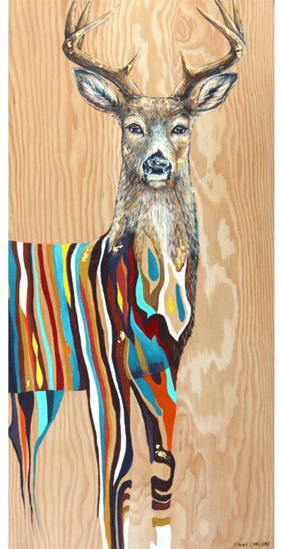
(10s) Don’t forget to employ all your Elements and Principles of Design. Keep objects/ scenes/ images neat and clean. Don’t rush. Use a variety of brushes. Practice first.

Sarah Carlson mimics the wood grain on the panel and uses it as a pattern within the objects. You can see her work at: www.sarahcarlson.ca

What is meant by post modernism?
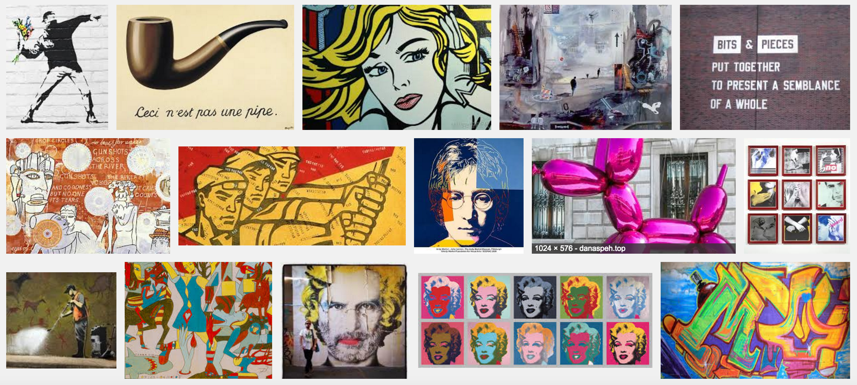
Results of a Postmodern artists google image search, May 2016
Postmodern art is a body of art movements that sought to contradict some aspects of modernism… movements such as intermedia, installation art, conceptual art and multimedia, particularly involving video are described as postmodern.
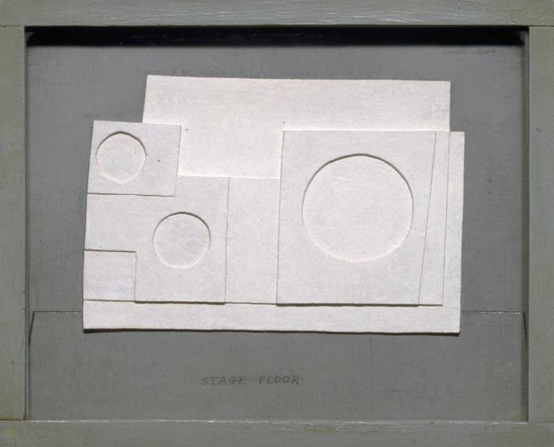
The close of the period of postmodern art has been dated to the end of the 1980s, when the word postmodernism lost much of its critical resonance, and art practices began to address the impact of globalization and new media.
Modernism refers to the broad movement in Western arts and literature that gathered pace from around 1850, and is characterised by a deliberate rejection of the styles of the past; emphasising instead innovation and experimentation in forms, materials and techniques in order to create artworks that better reflected modern society
http://www.tate.org.uk/learn/online-resources/glossary/m/modernism

Ben Nicholson OM
1934 project for Massine for Beethoven 7th Symphony Ballet 1934
Oil and pencil on board

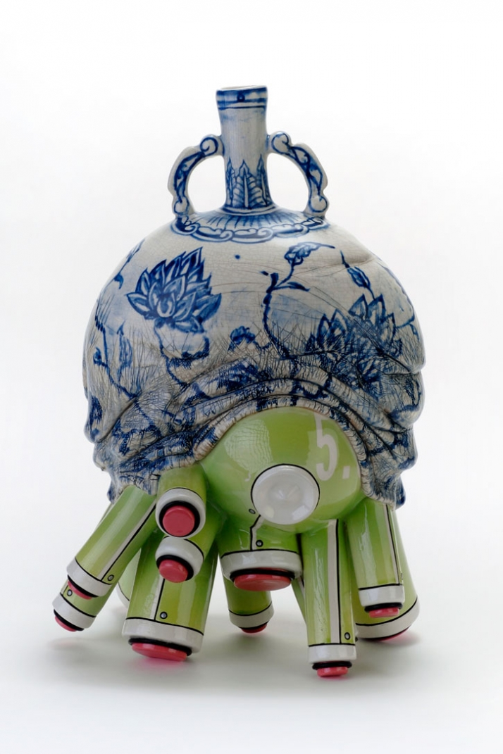
Brendan Tang
… my sense of belonging in the remix generation (as evidenced by electronic music and its "mash-ups"), that I tend to borrow and reconfigure ideas and influences to create works that I find both visually and intellectually compelling. I liken aspects of my artistic practice to channel surfing… I draw inspiration from such diverse realms as contemporary pop culture (e.g., plastic toys and Japanese comics), art history (e.g., in the form of Chinese Ming dynasty vessels and 18th century French rococo)...

… I am intrigued by cultural appropriation and hybridity. Undoubtedly, these predominant themes in my work are a reflection of my own ambiguous cultural identity.

