William Lyon Mackenzie C.I. AVI2O/3M
GRADE 10/11 Visual Art 201516
UNIT THREE: An Exploration of Portraiture & Media
From selfies to traditional portrait painting, the media can inform as much as body language, symbolism, objects and setting. In this project you are to explore artists, media and portraiture to produce a mixed media portrait that communicates through media and content.
ARTISTS REFERENCES:
“A portrait sounds like a relatively straightforward thing - a picture of someone - but across time it has proven to be a much more elusive beast. There are appropriated portraits, abstract portraits, portraits of pets, portraits of homes and desks and backpack contents, postmortem portraits, and portraits that are just piles of candy. For any rule you might devise to define a portrait, there is always a bona fide portrait that defies that rule.”
http://ca.complex.com/style/2012/10/25-awesome-contemporary-portrait-artists/

- Shaun Tan
- Angela Grossman
- Maihyet Burton

Shaun Tan is an Australian artist, writer and filmmaker. He won an Academy Award for The Lost Thing, a 2011 animated film adaptation of a 2000 picture book he wrote and illustrated.
http://www.shauntan.net/books.html
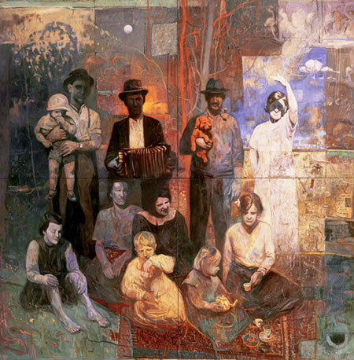
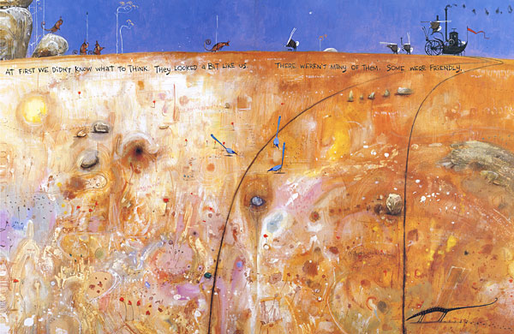
‘The meeting on the hill’ acrylic, gouache, ink and coloured pencil.

“Each medium works well for conveying certain ideas and effects, and this is what governs my choice, along with various experiments that often include mixing media.” Shaun Tan
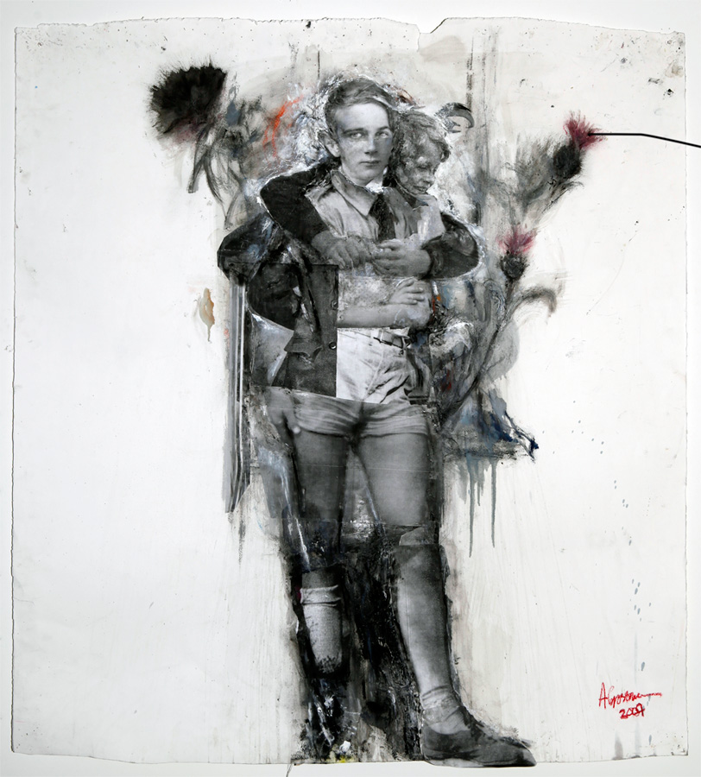
‘The hundred year picnic’ acrylic, oils, fabric & collage on canvas, approx. 4m x 4m.
Angela Grossmann, major contemporary Canadian artist, uses collaged materials to examine themes of identity, social displacement and adolescence.
Three Thistles
2009, mixed media on watercolour paper, 48 x 65 inches
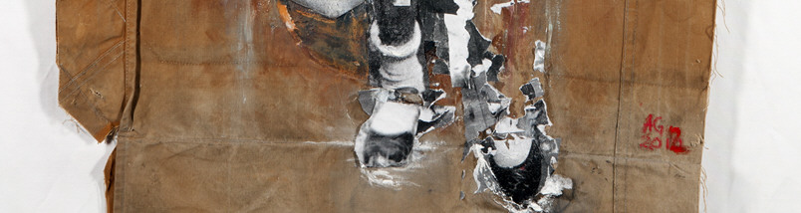
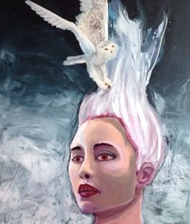
Maihyet Burton (Toronto)
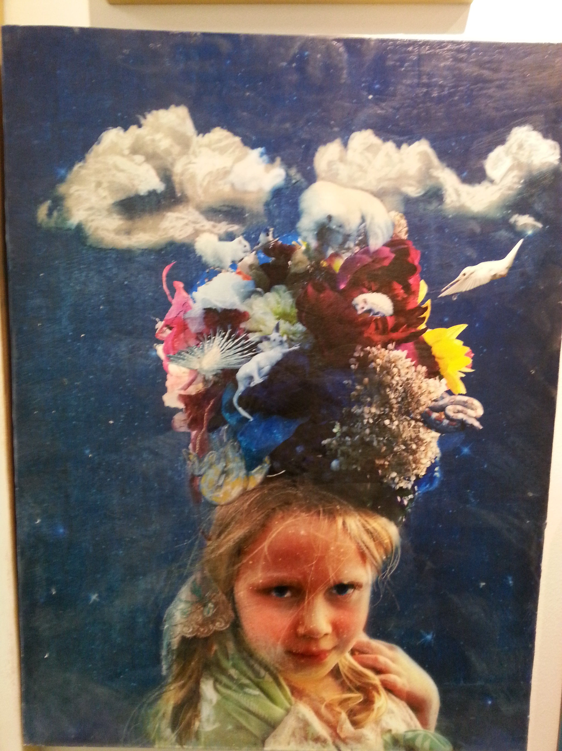
“She utilizes a multi-media approach involving paints, needle and thread and photographic collage. Her abstract, often childlike illustrations seek to juxtapose dream imagery with harsh reality, the dark and scary with the fanciful and joyous, and nature with the supernatural.”

http://www.maihyet.blogspot.ca/
Explore techniques of selected artists in order to produce a mixed media portrait.

TASKS:
Grade 10 – PORTRAIT INFLUENCED BY MAIHYET BURTON
- Take a variety of photographs/portraits and display as a digital contact sheet
- Complete a series of paint experiments and mix with collage and gel medium. See acrylic painting technique PowerPoint
- Explore an artists’ technique(s). Fill one sketchbook page, see Jonathan Leo example
- Cut out and display the photographs in your sketchbook with you media experiments. Think carefully about composition and never show the full face.
- Use exploration/experimentation, reflection, and revision to plan your final art. Document your creative process thoroughly in your sketchbook. Understand and elaborate on what and how your final artwork communicates a message- see prompts.
- Throughout this process you will also complete assigned sketchbook activities.

PROMPTS:
How could you use materials to create an art work to express aspects of your subjects personality?”
“What message do you want your portrait to communicate?
How might you use the principles of contrast and emphasis to underscore this message?”
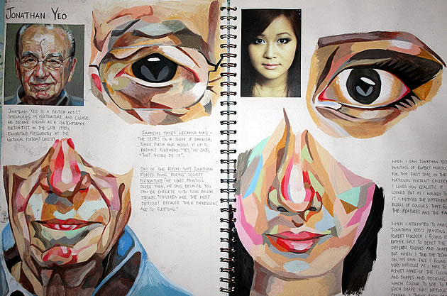
At its essence, a sketchbook page should provide insight into a student’s ideas and intentions, as well as revealing the influence of other artists. This sketchbook shows a dedicated and committed student learning a technique from an artist and then carefully applying this to original artwork.
Jonathan Leo

http://www.studentartguide.com/articles/art-sketchbook-ideas

TASKS:
Grade 11 – EXPLORE MULTIPLE ARTISTS TO INFLUENCE YOUR PORTRAIT
- Take a variety of photographs/portraits and display as a digital contact sheet
- Complete a series of paint (both oil acrylic) experiments and mix with collage and gel medium. See acrylic painting technique PowerPoint
- Explore artist techniques. Fill two sketchbook pages, see Chris Angliker example
- Cut out and display the photographs in your sketchbook with you media experiments. Think carefully about composition and never show the full face.
- Use exploration/experimentation, reflection, and revision to plan your final art. Document your creative process thoroughly in your sketchbook. Understand and elaborate on what and how your final artwork communicates a message- see prompts.
- Us the links to research portraiture. Display in your sketchbook
- Throughout this process you will also complete assigned sketchbook activities.
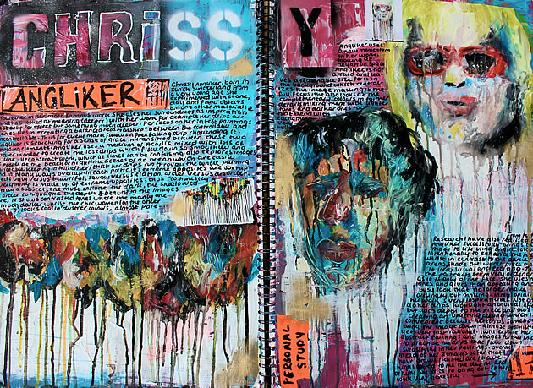
Here, the lavish, gestural, brush strokes contrast with careful annotation, resulting in a composition that oozes passion. Every speck of the page has been considered and worked over, using colours that integrate and link with the Chrissy Angliker artworks analysed. The whole page thus becomes an opportunity to absorb information from an artist; imbued with technique, emotion and style.
http://www.studentartguide.com/articles/art-sketchbook-ideas

LINKS/RESEARCH:
- Shaun Tan http://www.shauntan.net/
FAQ How do you make a finished illustration? http://www.shauntan.net/faq1.html

- Angela Grossmann http://art-history.concordia.ca/eea/artists/grossmann.html
A biographical dictionary of over seventy selected living artists in Canada

- Maihyet Burton: http://www.maihyet.blogspot.ca/

- A brief history of portraiture:
http://www.craftsy.com/blog/2013/05/the-history-of-portraiture/

- Contemporary portraiture article Complex Style:
http://ca.complex.com/style/2012/10/25-awesome-contemporary-portrait-artists/

Portraiture timeline
http://static1.squarespace.com/static/5452b6dae4b0c4d5c0fc9721/t/54f88c26e4b0093011dd691f/1425574950764/Plasencia%2C+Roseanna%E2%80%94History+of+Portraiture.pdf

http://www.studentartguide.com/articles/art-sketchbook-ideas

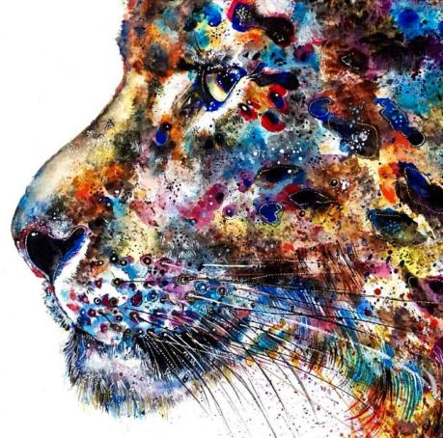
#1 SKETCHBOOK ACTIVITY GRADE 10
Watercolour Illustration Materials: 2B pencil, Watercolour, Fine-liner, gel pen and Watercolour paper
Create a light line drawing of a profile portrait (it can be human or animal as long as you have a reference) using pencil. Consider compositional placement on the page.
When you are satisfied with your pencil line sketch, paint using Water-colour techniques (from light washes to splatters), Colour Theory (mixing tints, using various colour schemes and shades), and concepts of value (light dark). You must practice and experiment with water colour techniques prior to starting this activity.
After your painting has dried, carefully and selectively apply fine-liner to draw lines in areas to emphasize areas of detail and enhance shaded areas and white gel pen to create highlights.

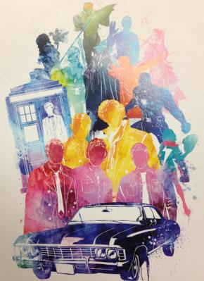
#2 SKETCHBOOK ACTIVITY GRADE 10
Mixed Media Shape Study
Materials: Your choice of materials, scissors, Xacto knife needle & thread, card, watercolours, inks, etc.
Create a design that uses only silhouette shapes of recognizable objects, accessories, etc. from popular culture. Assemble the cut-out shapes in an interesting composition. Apply markers, watercolours or inks around/over your shapes. Use scale for variety and contrast. You can also experiment with different textures for variety. Be creative, think outside the page! Strive for creating an interesting composition using shapes through your use of positive and negative space. Remove stuck on silhouette cut-outs once complete.
Note: Safety must be a consideration when using Xacto blades.

#1 SKETCHBOOK ACTIVITY GRADE 11
View from Behind- Materials: 2H pencil, fine-liner, colours of your choice and #2 paintbrush
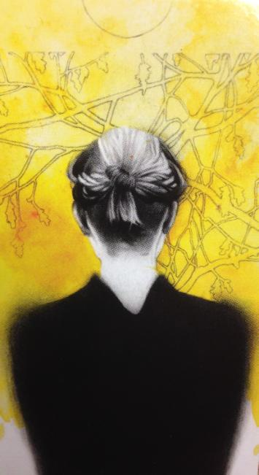
This drawing utilizes perspective/depth as the structural basis and your observational skills to draw the back of one of your school colleagues/friend or family member. Create a pencil line drawing in the middle of your page taking up half of the page. After use fine-liner to ink your lines, and ink wash to create shadowed areas.
Begin by sitting behind your model and observe the shape, lines, textures, values and space. Carefully work out the proportion as one object relates to another in scale, placement, and perspective on the page.
The space surrounding the figure should be decorated with a pattern/style creating a sense of wonder, amazement and the future. This must be your own ‘original’ creation/ interpretation using your choice of coloured pencils, inks, or watercolours.
After you ink your lines, observe where shadows have created areas of darkness; use a dampened #2 brush to bleed out ink lines to create the effect of darker values and shadows. Be careful not to “over bleed” by using too much water. Strive for depth in space and a balanced composition.

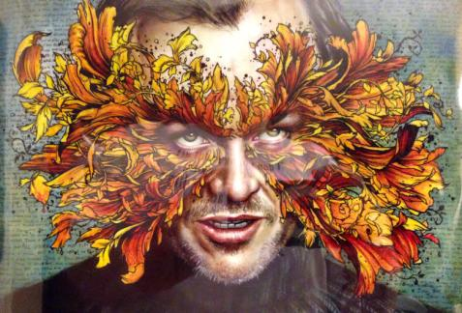
#2 SKETCHBOOK ACTIVITY GRADE 11
Appropriation Materials: Magazines, scissors, gel pen, permanent markers and glue stick
This activity concerns the appropriation of a printed image/photograph. Find a large portrait of a person in a magazine or newspaper (8X10 or slightly smaller). Large photocopies or computer printouts are acceptable as well. These portraits can be a model from an advertisement, a celebrity, a self- portrait, family member or friend. Make sure the image portrait is facing you. Then create a ‘disguise’ or ornamental mask on top of their face. Utilize your Elements and principles of design such as line, shape, texture, movement, balance, proportion, emphasis, harmony, etc.

NOTES
- Shaun Tan FAQ How do you make a finished illustration?
http://www.shauntan.net/faq1.html
“I usually paint from dark to light…I paint quite quickly in thin acrylic to start off with, and continue the editorial process of the sketches where I’m still changing my mind (hence the use of opaque media, where ‘mistakes’ can be covered). I then paint over these layers in oil paint…
I also work in other media… I also use collage frequently, because it allows unexpected elements to be introduced into a painting and creates an interesting texture, both of physical surface and ideas. Recently I’ve been experimenting with combining traditional media with new digital ones. Each medium works well for conveying certain ideas and effects, and this is what governs my choice, along with various experiments that often include mixing media.”

THE LOST THING (HD) A perfect example of humanity - Award Winning film by Passion Pictures
https://www.youtube.com/watch?v=S1JoliFXH74

http://www.studentartguide.com/articles/art-sketchbook-ideas

Week 1: Imagining, generating, experimenting
CRITERION | Level 4  (8 - 10) | Level 3  (7) | Level 2  (6) | Level 1  (5)
Plan / studies | Detailed plan/ experiments; contains required elements to complete final. | Clear plan / experiments contains required elements to complete final | Adequate plan contains required elements to start final | Limited plan. More planning needed in early stages.
Use of processing skills (e.g., analysing, evaluating, inferring, interpreting, forming conclusions…) | - uses processing skills with a high degree of effectiveness | - uses processing skills with considerable effectiveness | - uses processing skills with some effectiveness | - uses processing skills with limited effectiveness

Week 2-3: FINAL ART
Application / Creation | Expressive & detailed (where necessary).  Media / technology explored & applied with great skill. |  | Reasonably expressive & detailed (where necessary). Media / technology explored & applied with skill. |  | Competent (where necessary). Media or technology explored & applied. | Incomplete. More time needs to be taken in the planning stage.
Design /Composition | Student applies design principles (such as space, unity, contrast, balance, movement, direction, & emphasis) with great skill. |  | Student applies design principles (such as space, unity, contrast, balance, movement, direction & emphasis) with fair skill. |  | Student tries to apply design principles; overall result is not entirely successful. | Limited evidence of the elements & principles in the painting.
Communication: Four organising principles | Incorporates three of the principles effectively. Point of View is successfully communicated. |  | Incorporates two-three of the principles. Point of View is communicated. |  | Incorporates one of the principles: Hybrid | Minimal consideration of principles
Understanding of content (e.g., concepts, ideas, styles, procedures, processes, themes, informed opinions…) |  | – demonstrates limited knowledge of content |  | - demonstrates some knowledge of content | -demonstrates considerable knowledge of content | – demonstrates thorough knowledge of content

Week 3: Presenting, Reflecting & Evaluating
Use of critical/creative thinking processes  (e.g., creative and analytical processes, design process, exploration of the elements, problem solving, reflection, elaboration, oral discourse, evaluation, critical literacy, metacognition, invention, critiquing, reviewing) | - uses critical/creative thinking processes with limited effectiveness | - uses critical/creative thinking processes with some effectiveness | - uses critical/creative thinking processes with considerable effectiveness | - uses critical/creative thinking processes with a high degree of effectiveness

