William Lyon Mackenzie C.I. AVI2 /3

GRADE 10/11 VISUAL ART
Project 2 Sketchbook Work: Forgetting the hand
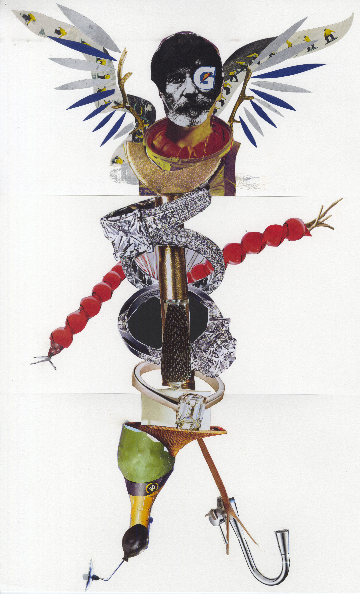
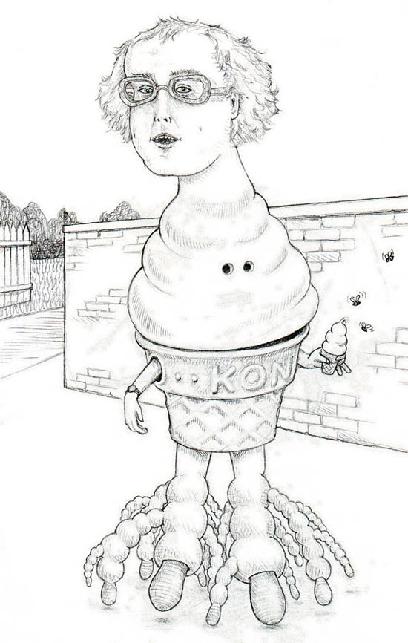
Objectives: Planning/sketch in preparation for an elaborate game of exquisite corpse, passed back and forth between the artists (the students) until a collaborative conclusion is reached.

- Fill a page of PRACTICE HAND SKETCHES
- DRAW one hand on a single sketchbook page.
- Fill the positive or negative spaces with drawings of objects and symbols that mean something to you.
- Using a pen INK and CROSSHATCH to complete
- FINISH the exquisite corpse drawings by adding details and different media e.g. pen, collage, watercolour paint, pencil shading and colour pencils
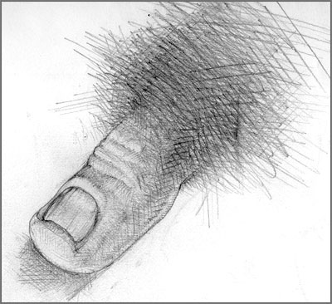
Crosshatching and shading
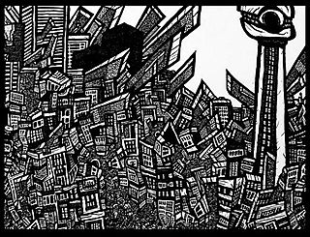
Artist References
TORONTO ARTIST: MIKE PARSONS
Born in Scarborough, Ont.
Went to OCAD to study film

“Cartoons about the city…The lights and the darks are the celebration and the worry in the city. So I always draw silly and scary stuff about head phones and technology and the fast pace of the city. But I always like to make it silly and satirical, because it’s a celebration and a warning. I love the city and stuff like this and all the people. But then we also stress ourselves out here and it’s a little too much.”

SKETCHBOOK DRAWING:

 

