Artist Statement
Upcycling is the process of converting waste materials or useless products into new materials or products of better quality or for better environmental value.

•Title: _________________, Name:________________
•Media: ________________ e.g. found object, mixed media, wire, egg boxes…

•One or two paragraphs. An artist statement is what and why you do what you do, from your perspective.

QUESTIONS
- What were you trying to show/express?
- How did you transform your object?
- How were you influenced by an artwork, artist or an art movement? OR what connections can you make?
- How does it connect to Upcycling principles?

Reflection
- What have you learned during the creative process for this project about art and about you as an artist?
- What makes your work original?

For example
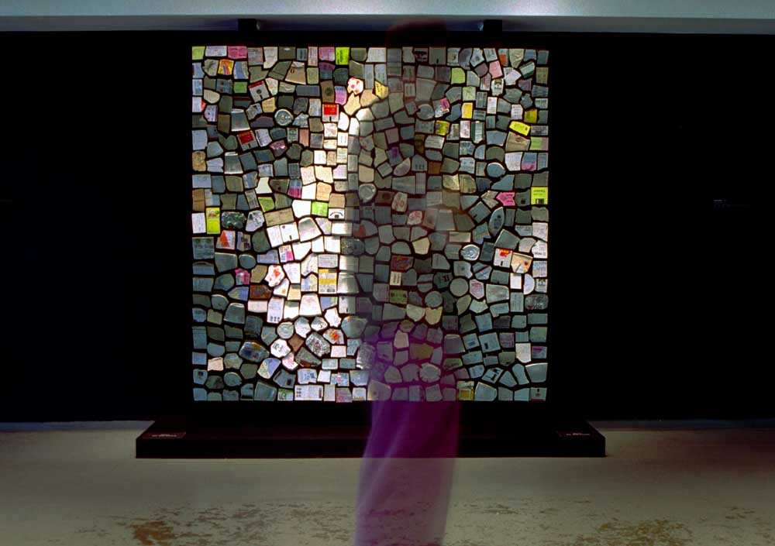
Trash Mirror - 2001
500 pieces of variously colored trash collected from the streets of New York and artist’s pockets, motors, control electronics, concealed video camera, computer. Size - W 76" x H 76" x D 8" (193cm ,193cm, 20cm) Though built 3 years after the Wooden Mirror, Trash mirror was conceived first, However the concept seemed too risky at the time so I decided to build the Wooden Mirror first. This piece suggests that we are reflected in what we discard. The piece celebrates the ability of computation to inflict order on even the messiest of substances - trash.

