Artist Statement
CREATIVE CHALLENGE: explore and experiment with media, including alternative media, to generate and elaborate on ideas for the creation of art works through layering. Think critically about your use of media and choice of imagery, consider a variety of conventions, e.g., allegory, expressive exaggeration, approriation, juxtaposition, synectics etc.
Artist Inspiration: Angela Grossman an influential Canadian artist

•Title:_________________, Name:________________
•Media:________________
e.g. Digital Photography and image manipulation software

•One or two paragraphs. An artist statement is what and why you do what you do, from your perspective.

QUESTIONS
- What were you trying to show/express?
- How did you create your image?
- How were you influenced by an artwork, artist or an art movement? OR what connections can you make?

For example
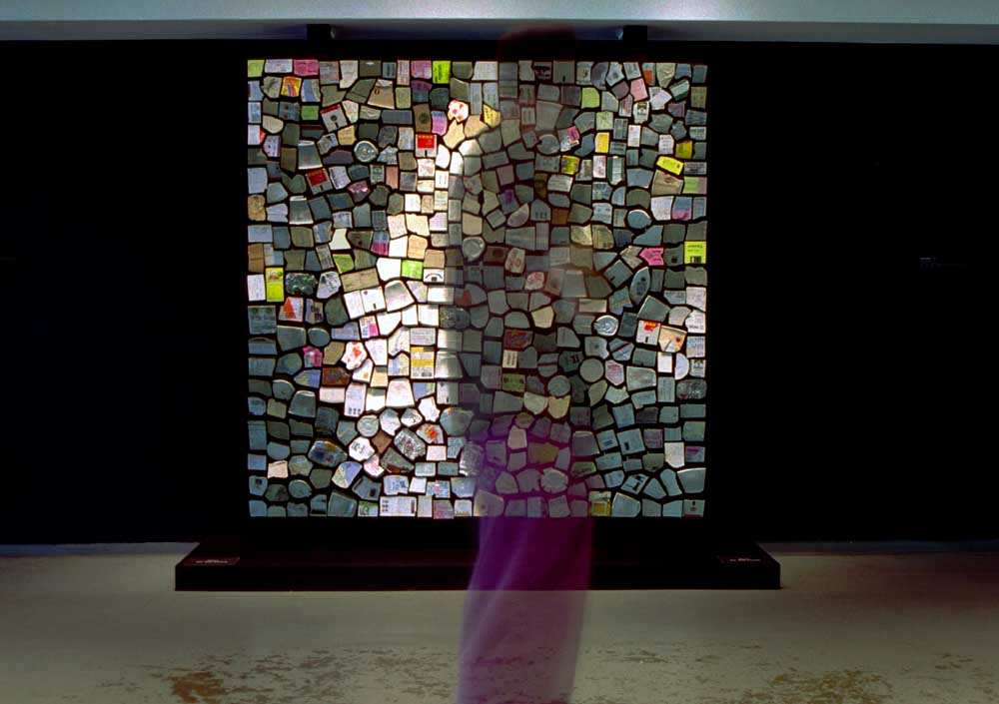
Trash Mirror - 2001
500 pieces of variously colored trash collected from the streets of New York and artist’s pockets, motors, control electronics, concealed video camera, computer. Size - W 76" x H 76" x D 8" (193cm ,193cm, 20cm) Though built 3 years after the Wooden Mirror, Trash mirror was conceived first, However the concept seemed too risky at the time so I decided to build the Wooden Mirror first. This piece suggests that we are reflected in what we discard. The piece celebrates the ability of computation to inflict order on even the messiest of substances - trash.

