ARTIST PRESENTATION

You are to make a short presentation and a class information sheet on an artist or movement from any time period of your choice.
Focus on a specific artist and include multiple examples of their work in regards to their time period. Another way you can do this is to research a specific art movement and speak about the artists who help create the genre.

Your information sheet must include:
- One significant artwork
- Artist biographical information
- Art movement(s) information
- Two questions that everyone should be able to answer based on your presentation and information sheet
- 4-5 Resources

It must be one-two sides ONLY. Do not just print out from a website and do not include any information or vocabulary that you do not understand.
Relate your choice of artist/art movement/time period to the work you want to pursue in life or study in post secondary education.

Presentation Suggestions:
- Use a board or case in the hallway to create an artist specific display/installation
- 5-10 minute presentation using Powerpoint, Prezi, Keynote…
- Short film/animation or documentary
- Create a trivia game/activity for the class to undertake
- Create a piece of work that is inspired by your artist

Curriculum Expectations:
A3) Production and Presentation: produce art works using a variety of media/materials and traditional and emerging technologies, tools and techniques, and demonstrate an understanding of a variety of ways of presenting their works and works of others
B1) The Critical Analysis Process: demonstrate an understanding of the critical analysis process by examining, interpreting, evaluating, and reflecting on various art works.
B2) Art, Society and Values: demonstrate an understanding of how art works reflect the society in which they were created, and how they can affect both social and personal values.
C1) Terminology: demonstrate an understanding of, and use correct terminology when referring to, elements, principals, and other components related to visual arts.

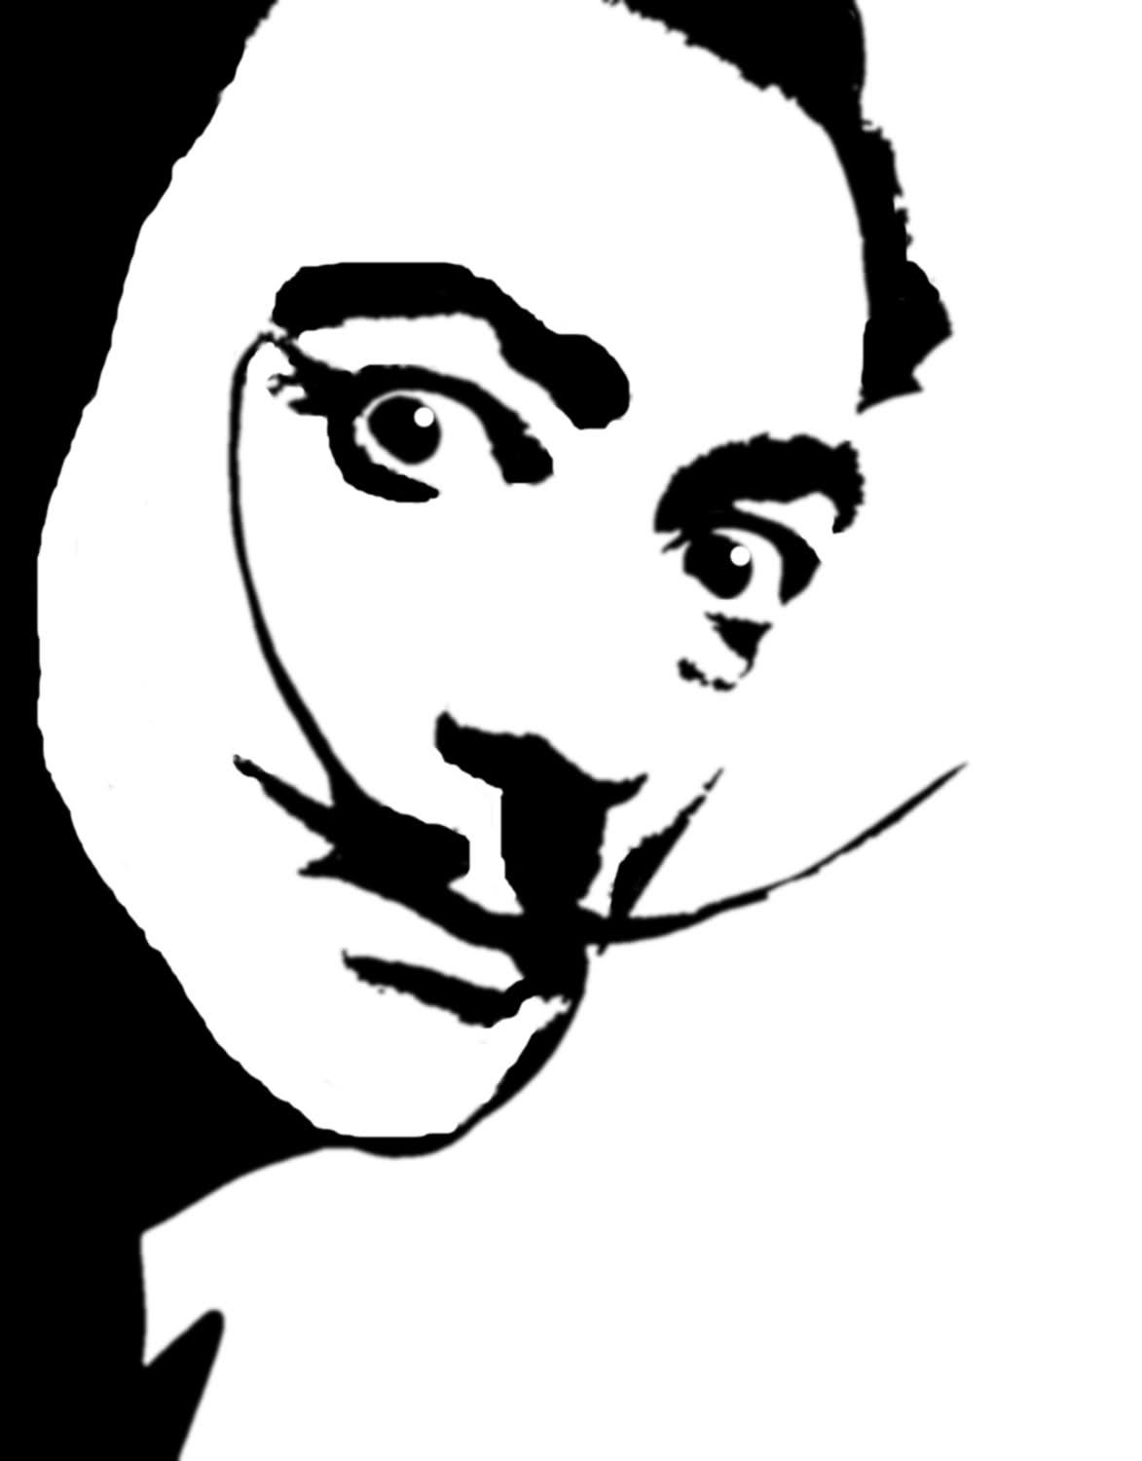
ART IS DESTRUCTIVE, BUT IT DESTROYS ONLY WHAT IT CONSIDERS TO BE SHACKLES LIMITING OUR VISION

