Andy Goldsworthy
Biography
Andy Goldsworthy was born on the 26th of July 26th 1956 in Cheshire, England. Goldsworthy grew up in Leeds and at the age of 13 he began working on a farm. Through his farm work he gained an appreciation and fondness of nature which he would later incorporate into his artwork.
Andy Goldsworthy studied fine arts from 1974 to 1975 at Bradford College of Art; he then transferred to Preston Polytechnic and in 1978 received his Bachelor degree in art.
He is currently works in Scotland and continues to make his environmental art.
Art movements and styles
Andy Goldsworthy is a postmodern environmental artist. He works with natural material in his artwork such as leaves, rocks, sticks, dirt, grass, and flowers. Goldsworthy works on projects both large and small in scale. Most of his artworks are transient in nature, meaning that they only last for a short amount of time and then cease to exist.
His work is entirely natural and he chooses to use organic media because he wishes to use material that cannot be edited to “represent nature as a whole.” This method allows him to create art pieces that express value in colour and thought provocation. However because his material naturally decays or separates, he displays his artworks in the form of photographs.
Goldsworthy cannot bring his audience to the locations of his work, but with the use of photos, he can bring his environmental pieces to his audience. Photos also allow him to show the exact composition and time that the artworks exist in; this way the audience are aware of the decaying factor in his art while still enjoying it fully. "Each work grows, stays, decays – integral parts of a cycle which the photograph shows at its heights, marking the moment when the work is most alive. There is an intensity about a work at its peak that I hope is expressed in the image. Process and decay are implicit."
Some people interpret the transient factor of Goldsworthy’s work as a representation of humanity and mortality. The artworks exist in the moment of their creation and eventually fall apart, like how all living organisms eventually cease to live. Humans wish to make an impact on the world during the time of their existence, like how Goldsworthy’s work can show beauty and impact viewers before fading away.

Questions:
What type of medium does Andy Goldsworthy use to create his art works? Name two types of material.
Natural and Organic material: leaves, rocks, dirt, etc.
Why does Andy Goldsworthy take photographs of his work instead of bringing them to exhibitions?
Most of his works are transient and/or immobile. Photographs allow viewers to experience artworks that have been destroyed by time or are located in inaccessible areas.
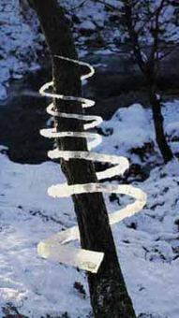
Ice Spiral: Treesoul
This art piece was created by snapping large icicles and connecting them into a spiral formation around a tree. The spiral is connected to the tree at the top and gradually thicker down. The pieces are connected by snapping apart icicles and connecting the broken parts together with saliva. This process is time consuming and must be done early in the morning in order for the saliva to freeze the pieces in place.
The spiral is interpreted to represent the energy of the tree and the cycles in its life. Throughout a tree’s life, it experiences the cycle of life and death of the organisms around it as well as the cycle of the seasons. As the tree grows older its energy becomes stronger which is represented by the spiral becoming thicker the closer it is to the ground.
This piece shows the transient aspect of Goldworthy’s art. The artwork can only last for a few hours once the sun temperature rise. The time it took to create the sculpture is far greater than how long it lasts. The usage of photography captures the existence of the artwork and immortalizes, allowing others to view it.
Ice Spiral: Treesoul
December 28th, 1995
Glen Marlin Falls, Dumffrieshire, Scottland

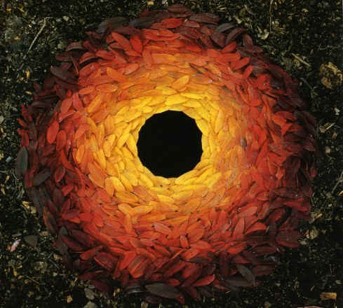
Rowan Leaves and Hole
This artwork reflects the humanity and mortality aspects of Andy Goldsworthy’s projects. It is comprised of brightly coloured leaves placed in a circular fashion around a hole in the ground. The leaves become brighter closer to the center, starting from dark crimson on the edge of the circle to bright yellow on the inside. The black colour of the centre contrasts the bright colours of the leaves.
This can be interpreted as how before they die, humans use their lives to accomplish beautiful things and impact the world around them.
Rowan Leaves & Hole
October 25th, 1987
Yorkshire Sculpture Park

Resources Used
"National Gallery of Art." Andy Goldsworthy: Roof. National Art Gallery. 2004. Web. 27 Nov. 2015.
Beckly, Sam. "#6 - Ice & Snow Exhibit." Westonsworld. 13 Nov. 2011. Web. 27 Nov. 2015.
Stonard, John Paul (10 December 2000). "Goldsworthy, Andy". Grove Art Online
Rivers and Tides. Dir. Thomas Riedelsheimer. Docurama ;, 2001. Film.

