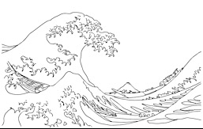
K A T S U S H I K A H O K U S A I
ARTIST INFORMATION SHEET

BY CLARA CHANG

WHO IS HOKUSAI

Hokusai is a Japanese printmaker and painter who was known for his dramatic nature landscapes and his lively portraits. Hokusai aimed to capture the beautiful land and the unique culture of his country. Many of his landscape prints were considered to be “western art seen through a Japanese eye.” He was highly influenced by Dutch and French landscape painters and the way they expressed perspective and realistic shadows. He also was clearly inspired by the traditional Japanese print-making techniques however; he focused on the serenity of nature and the unity of man rather than traditional subjects such as shoguns, samurai and geisha.

THE GREAT WAVE OFF KANAGAWA
Year: 1830–33
Type: Color Woodblock
Dimensions: 25 .7 × 37. 8 cm

The Great Wave Off Kanagawa is the most famous print created by Hokusai. The art piece depicts a strong wave about to swallow the boats in the sea with sailors inside.

This art piece is part of a series of prints titled, “Thirty-six view of Mount Fuji”. Thousand and thousands of copies were produced of this artwork and were very quickly sold at a cheap price.

In this art piece and the rest of the art pieces included in the series, viewers can spot the Fuji Mountain. This this particular art piece, the foreground is dominated with the massive wave with the Fuji Mountain in the back, almost unrecognizable.

Hokusai did not believe in realism. He focused more on color and optical play. For example, you can see the spray from top of the crashing wave looks like snow falling on the mountain.

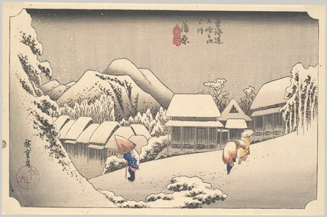
YORO WATERFALL IN MIRO PROVINCE

Year: 1832–1835
Type: Color Woodblock
Dimensions: 38.2 x 25.4 cm

This piece was finished in 1833 and installed as one of the eight prints in the collection A Tour of Waterfalls in the Provinces. In this print, Hokusai features the Yoro Waterfall in the centre with a trail and foliage surrounding it. The traditional meaning of a waterfall in Japanese culture refers to an ancient Shinto ritual called Misogi. Misogi is the practice of washing oneself under a waterfall in order to cleanse and purify the body and soul. Though the western culture does not have a deeper meaning for waterfalls, many people regard the Falls as beautiful, relaxing and almost magical place which is similar to the mood Hokusai was trying to show in this art-piece.

ART MOVEMENT: UKIYO-E

During the Edo Period from 1615 to 1868, a new art movement was created. This movement was called, Ukiyo-e or also known as, “Pictures of the floating world.” Originally Ukiyo-e meant sadness (uki) of life (yo), however after the 17th century, uki translated to the meaning, “to float”. Instead of putting a negative connotation to it, the Japanese associated the word, ukiyo-e “with the momentary, worldly pleasures of Japan's rising middle class.”

As people had more money and time for leisurely activities, for first time in Japan’s history, people began to commission painters. At that time, many people looked down on artists who created a new style based on contemporary subjects, bright colors and curving lines. These art works were created as paintings but later on developed into woodblock prints. As Ukiyo-e became more popular amongst artists, the general public became more accepting of the art form and eventually ukiyo-e become a part of Japan's popular culture.

As mentioned above, ukiyo-e were paintings and later produced more as prints. When produced as paintings, artists usually used black ink and more colors were added to enhance the complexity. When creating woodblock prints, the process was more rigorous. First: painting a design with ink. Second: carving the design onto wooden blocks. Three: applying colored ink to the blocks and pressing sheets of paper on them to print the design.

The purpose of creating woodblock was to mass produce the prints and circulate the art pieces amongst the public. Although the process of creating the first print was very complex, once completed it became much easier to reproduce the same art.

Amongst many Japanese artist during that time, Hokusai is one of the more well known artist that represents the Ukiyo-e movement. His unique shapes, colors and layout attracted many western artists and had a major influence on them. They were amazed by his expressive curves, bold use of colors, and liberal designs.
QUESTION & ANSWER TIME

1. What are the steps to creating a woodblock print?

2. How did the subjects in Hokusai’s paintings differ from most artists’ at that time?
RESOURCEFUL LINKS

https://www.khanacademy.org/humanities/art-asia/art-japan/edo-period/a/hokusai-under-the-wave-off-kanagawa-the-great-wave

http://www.metmuseum.org/toah/hd/ukiy/hd_ukiy.htm

http://archive.artsmia.org/art-of-asia/explore/explore-collection-ukiyo-e.cfm

http://www.katsushikahokusai.org/biography.html

