Musical Elements and Principles Artist Statement

•Title:_________________, Name:________________
•Media:________________
e.g. Acrylic paint, pencil…
•One or two paragraphs. An artist statement is what and why you do what you do, from your perspective.

QUESTIONS / PROMPTS
- What music was your inspiration? How did that influence your artwork?

- Why did you choose the colour scheme?

- What are the two most prominent Elements and how did their application improve your art?

- What is the most prominent Principle and how does it connect to your music?

For example
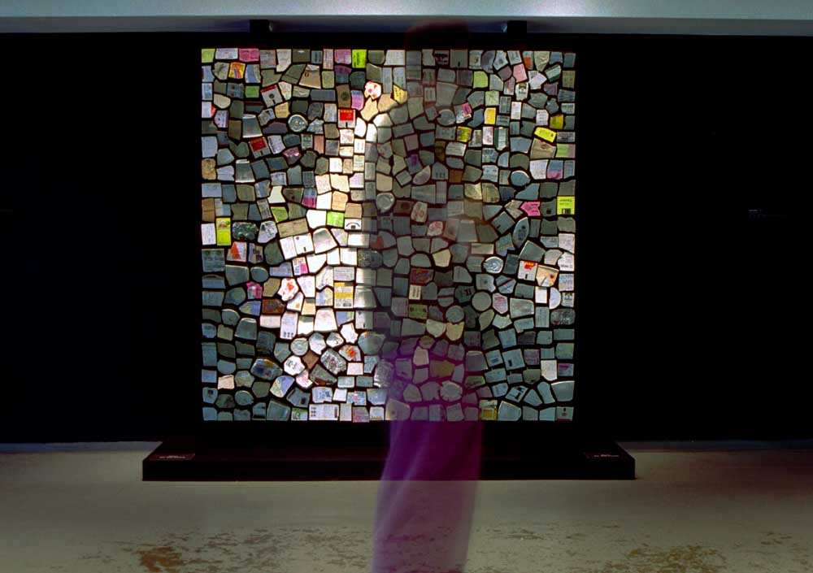
Trash Mirror - 2001
500 pieces of variously colored trash collected from the streets of New York and artist’s pockets, motors, control electronics, concealed video camera, computer. Size - W 76" x H 76" x D 8" (193cm ,193cm, 20cm) Though built 3 years after the Wooden Mirror, Trash mirror was conceived first, However the concept seemed too risky at the time so I decided to build the Wooden Mirror first. This piece suggests that we are reflected in what we discard. The piece celebrates the ability of computation to inflict order on even the messiest of substances - trash.

The student demonstrates  the specified knowledge and skills with... | a high degree of effectiveness | considerable effectiveness | some effectiveness | limited effectiveness
Concept: Transfer of knowledge and skills (e.g., concepts...) Making connections (e.g. between the arts and personal experiences...)  Communication | Level 4 | Level 3 | Level 2 | Level 1

